Richard Welter
CH293
Dr. Lockyear
December 8, 2013
Review on Microfluidics Technologies

Introduction

Microfluidic technologies are a relatively recent advance in the general field of Analytical Chemistry. Microfluidic systems have been developed for many applications, including forensic science, biochemistry, and related fields. Prior to the introduction of microfluidics, conventional separations were done using large amounts of sample and solvents, and analysis times were long. Microfluidic devices have enabled a great reduction in sample size and solvent waste by decreasing the overall size of the separation channel. Moreover, multiple sample handling processes can be included in one microfluidic device, reducing the time spent and possible errors inherent in external sample handling steps. These so-called micro-Total Analysis Systems, or μ-TAS (Harrison, 1993), have enabled a number of important advancements in drug discovery, process control, and healthcare, among other things.

Historical Content

The micro-Total Analysis System initially required photolithography and chemical etching to form the sample handling channels on glass microchips (Harrison, 1993). These systems employed conventional capillary electrophoresis for fluid movement as well as for sample separations. The surface of the glass channels functioned nearly identically to the fused silica capillary in providing fluid control in the presence of an electric field (Mowry, 1999). In past experiments, which required moving parts, the newly reduced chip dimensions now allow additional advantages to the development of sensors and actuators by reducing solvent and sample consumption and decreased analysis time. From integrating multiple processes to form a sample pretreatment-separation-detection system all on one chip, the reduced size of the chip used for electrophoresis thus allowed additional reduced costs. In addition, a common setback apparent in the electrophoresis process was the leakage phenomenon (Harrison, 1993). Within the channels, if the potential on one of the side channels is left uncontrolled, it will experience a laminar effect, a pressure differential that creates a convective flow out of the side channel, which results in the fluorescent dye in the vertical channel to mix with the buffer in the horizontal channel directly at the intersection point (Mowry, 1999). Another cause of the leakage phenomenon is the ionic strength in the buffer. During the electrophoresis process, the ionic strength of the buffer solution depletes over time. Due to the depletion, adding more buffer into the channel was thought of as an appropriate method. However, by adding more buffer in the channels during electrophoresis causes a flux in the ionic strength of the buffer concentration, resulting in leakage. To resolve such phenomenon, there were numerous trial and error manipulations. More specifically, by increasing the applied potential on all the reservoirs that contact the intersection created a more concrete flow from buffer and fluorescein reservoirs to the waste reservoir. Furthermore, when the two solutions mixed at the intersection point, the fluorescein dye diluted. Such overall dilution effect allowed the solution to travel successfully downstream of the intersection. Because of this concrete flow, there were minimal evidence of leakage. This improvement provides a sufficient route that will lead into further advances to the development of microfluidics on a chip (Harrison, 1993).

Given the success of Jed Harrison’s experiment on a miniaturized chip, researchers from then on wanted to perform additional experiments to determine if any potential effects of variable manipulation could capitalize on that success. For more efficient results, changing the design of the substrates within the chip to avoid convective leakages to what specific type of glass chip to be used are examples of such variable manipulation. First, the width of the channels played a role into how well the miniaturized chips performed. Though the depth of the channel did not change from the previous publication discussed prior, three designs were created: Airport-30 (A), Airport-70 (B), and Airport-70:70 (C) shown below:

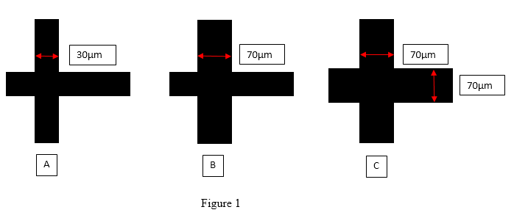

While size of the channel is a noticeable manipulative variable, the etching of the glass chips also played an essential role in the separation process. Glass chips that were isotropically etched, relatively smooth with a characteristic curvature (Harrison, 1993), had better performances that were not annealed—a process that removes stress from the glass. Manipulating the size of the channels did in fact show evidence of capitalization, such as very rapid amino acid separations due to less leakages spotted, comparing the data of Airport-30 versus Airport-70 specifically. This demonstrates the potential of these CE systems to compete with chemical sensors in terms of analysis time, a well establishing advantage of micromachining a miniaturized chip over conventional CE systems. In addition, higher electric fields caused by high thermal conductivity and the mass of the glass substrate is another advantage over conventional CE. Remarkable conclusions in this experiment included that the choice of glass substrate showed an incredible importance to the quality of the channels. Because of the choice of glass, there was an overall improvement in the device yields, something that the researchers were hoping for in such capitalization (Fan, 1994).

Now, at the same time Zhonghul Fan and Jed Harrison were finding ways to capitalize such success discussed prior, there were similar research endeavors happening, too. A competing group under Stephen Jacobson manipulated the separation lengths in the microchip as well as field strengths for total evaluation. Seeing that smaller column dimensions allowed the power to dissipate more efficiently, separation devices were shown to allow higher electric field strengths. Furthermore, this efficiency resulted in remarkable improvements: Joule heating, contributor to the dispersion of the analyte band, is minimalized; and with higher electric field strengths, performance of separation is faster, thusly minimalizing dispersion of the analyte band. Though the substrates were identical to the microchips used in Zhonghul Fan’s experiment in regards of two perpendicular substrates intersecting, a cover slip was used to close the channels, an efficient way to save costs. The newly revolutionized chip is shown below:
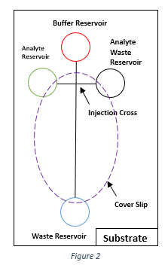
Furthermore, rather than performing CE via separation, the “pinching” method was performed alongside with separation. Results in this experiment found stability of the volume of the analyte plug when pinching the flow of the analyte. However, although the manipulation of the field strengths slightly made the plug asymmetrical, the field strengths did not influence the actual stability of the injection plug. Furthermore, since the channels had a slight trapezoidal geometry shape, it was found difficult to cut the plug when applying different potentials during the switch from sample loading to separation modes on the upper corners. But there was a major advantage found in this experiment: with laser-induced fluorescence, the point of detection can be placed anywhere along the separation column, a major breakthrough to the planar microchip design. This is important because prior, researchers believed only fluorescent species were amenable to electrophoretic separation (Jacobson, 1994).

Furthering the capitalization of microfluidics, reduction of the cost to make such devices was a major concern. Later developments in micro-TAS have involved the design and fabrication of microfluidic systems in polymeric substrates. Because polymers are very malleable in comparison to glass and silica, replicating polymeric substrates lead to inexpensive mass fabrication. Specifically in this experiment, poly (dimethylsiloxane)—or PDMS—was introduced to compare the nature of electrophoresis versus the traditional glass microchip. PDMS is a durable hydrophobic material that can be reversibly bonded. Furthermore, PDMS is optically transparent, thus actually viewing the separation process. The channels in the PDMS chip was revolutionized as well, shown in the figure below:

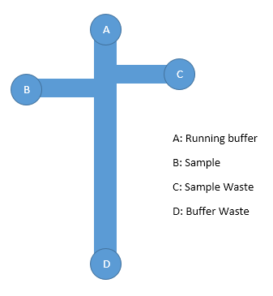
Figure 3
Instead of the traditional perpendicular cross-section used in prior experimentation, this newly developed substrate is more geometrical, thus avoiding hindrances such as leakage. After running the separation process, one result was that reversing the polarity did not result in current change, indicating cathodic electroosmotic flow (EOF)—the transport of neutral molecules or particles by a conducting solution under the influence of an electric field (Mowry, 1999)—over the buffer systems. In addition, since there was a consistency of cathodic EOF, it further indicates a negative charge present on the walls. This discovery was essential when considering adsorption of hydrophobic anions such as sodium dodecyl sulfate (SDS). SDS is a spherical, critical micelle—created in buffer solution by adding surfactant molecules—concentration. The interior is nonpolar whereas the exterior is polar. Essentially in Micellular Electrokinetic Capillary Chromatography (MECC), neutrals will partition between the interior of the micelle and buffer “mobile” phase (Mowry, 1999). By adding SDS to the PDMS chip, there was an increase in EOF at high concentration. This further shows that there is some signs of pH dependence of EOF. A hallmark resultant from this experiment was that the adsorption of SDS indicated that there is value of hydrophobic interactions in governing PDMS devices. Furthermore, PDMS devices require continuous voltage of all intersecting channels in order to avoid leakages at the intersections, contrasting the behavior of glass substrates. Another advantage of polymeric devices in comparison to glass substrates was the multi-stacking technique used for the PDMS chips. The coupling scheme presented a simple solution for the interconnections with zero dead volume, a common plight in glass substrates. (Ocvirk, 2000).

Conclusion

The beauty of microfluidic technologies is not only the success this application has provided to current natural scientific fields, but how researchers can use prior findings to discover even better alternatives. In this review specifically, the transition from glass substrates to polymeric devices is a perfect example to such capitalization; needless to say there is more likely even more breakthroughs I have yet explored. However, there are both advantages and disadvantages in glass and polymeric devices. For glass substrates, EOF is more stable than polymeric devices. However, with glass devices if the channels get plugged, the chip is basically trashed and useless. With polymer devices, the material itself is its own worst enemy. Though it is cheaper and easier to make, the surface is not as concrete as glass. Therefore, the surface needs to be modified. In addition, glass substrates are easier to clean, unlike polymers. When cleaning polymeric devices, one could potentially have to redo the modifications due to the poor surface. But overall, when it comes to the ultimate decision, price cost is what dictates the ultimate use between glass substrates and polymeric devices.
Despite the material used for electrophoresis, another account to take into consideration is the actual design within the material, such as deciding the depth and width of the channels, whether to have the channels curve or to have the cross-intersection design, and how long or short the channels are. These are important factors when constructing the “perfect” chip to avoid what these researchers struggled to comprehend, like the leakage phenomenon—though the leakage phenomenon is its own catch-22 and anything manipulative can cause it to happen.

Work Cited
Fan, Z. H.; Harrison, D. J. Micromachining of Capillary Electrophoresis Injectors and Separators on Glass Chips and Evaluation of Flow at Capillary Intersections. Analytical Chemistry. 1994, 66, 177-184.
Harrison, D.J.; Fluri, K.; Seiler, K.; Fan, Z.; Effenhauser, C.S.; Manz, A. Micromachining a Miniaturized Capillary Electrophoresis-Basis Chemical Analysis System on a Chip. Science. 1993, 261, 895-897.
Jacobson, S. C.; Hergenröder, R., Koutny, L. B.; Ramsey, J. M. High-Speed Separation son a Microchip. Analytical Chemistry. 1994, 66, 1114-1118.
Mowry, Curtis D.; Kelly, Michael J. Capillary Electrophoresis. In Encyclopedia of Applied Physics, Update 2; 1999, 3-33.
Ocvirk, G.; Munroe, M.; Tang, T.; Oleshuk, R.; Westra, K.; Harrison, D. J. Electrokinetic control of fluid flow in native poly(dimethylsiloxane) capillary electrophoresis devices. Electrophoresis. 2000, 21, 107-115.

