Microfluidics Technologies
Richard S. Welter

Introduction

This assessment is a culmination of what I did during the fall and spring semesters. Due to changes by our collaborator, Dr. Chris Culbertson, we switched from LIF to Mie scattering for detection. However, we are still performing capillary electrophoresis, but on-chip instead of a capillary. In October, Dr. Lockyear and I went to Kansas State University to visit Dr. Culbertson’s laboratory in order for us to get a better understanding of the new project. We received a sample of microspheres from him that were submerged in a buffer solution. Unfortunately, our sample dried up, and needed to be reconstituted. The microspheres were constituted in a buffer solution prepared by mixing 1.44181g Sodium Dodecyl Sulfate (SDS) (86, 201-0; Aldrich Chem. Co., Milw., WI) and 3.8174g Sodium Tetraborate Decahydrate (Borate) (B9876-5006; Sigma-Aldrich, St. Louis, MO) in 1.0 L DI water. I tested the pH of the solution, but it was too acidic. To reach the appropriate pH of 10.00, I had to add 4.5 mL of 3.0M NaOH, which was prepared prior to creating the buffer solution. Now that the buffer solution was prepared at an appropriate pH, I was able to reconstitute the microspheres by submerging the bead in 1.0 mL of the borate buffer. Then I diluted the spheres and buffer solution with 100.0 µL DI water. Reconstitution was successful, through evidence of particles under our microscope.

Redesigning Instrument

After our visit to Kansas State, we had to order new parts for our laser assembly. We ordered Lens “PC x 25 x 300” (Edmund Optics, Barrington, NJ), which was mounted between the laser source and mirror that is reflected onto the microfluidic device, as shown in Figure 1. We were successfully able to align the laser onto the microfluidic device, shown in Figure 2.

Preparation and Separation of Microfluidic Device

All chips that will be discussed were prepared in Manhattan, Kansas.

Before using the microfluidic device, cleaning the channels is of importance. Cleaning the microfluidic device (SU-8 2005) calls for DI water and borate buffer to be pulled through the channels using suction. SU-8 2005 seemed very dirty when I retrieved it for experimentation. I continued with the chip, however, because it was only dirty on the outside and not in the channels, and I did not think it would affect the overall separation process. Though I could see the fluid traveling in the channels as expected, when voltage was applied, there was not a stable reading, indicating no electroosmotic flow. This can be because of presence of bubbles in the channels.

For a second attempt, I used a different PDMS microfluidic device (T.B. 8). The chip was a lot cleaner than the chip I used prior. I prepared the chip similarly to SU-8 2005. After preparing the chip, I added my sample and borate buffer into the reservoirs, and as I applied voltage, the reading was not consistent, ranging from 0.018-0.026V. When I attempted to run the sample, the voltage immediately dropped to 0.002V and had no evidence of peaks. I checked the channels under the microscope, and did not observe any evidence of bubbles. Bubbles may have been right at the entrance to a reservoir, though—those are more difficult to catch.

Conclusion

This semester was beneficial for me because I got a taste of what it truly means to conduct research. Not all experiments will run as expected, and being a scientist requires patience, a positive attitude, and sufficient background on the topic. I have great appreciation in this field, and I know that microfluidic technologies will become of great importance in future work, as I see it is becoming widely used in numerous health-related fields.

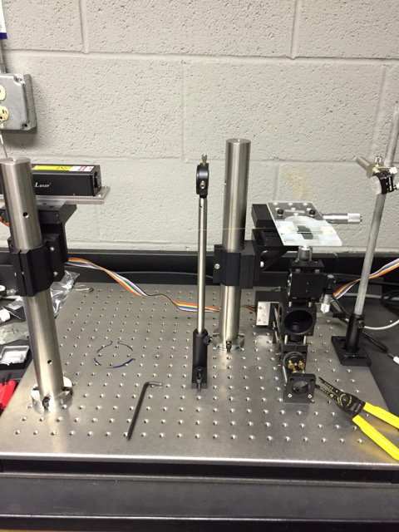

Figure 1. New set-up of our laser instrument.

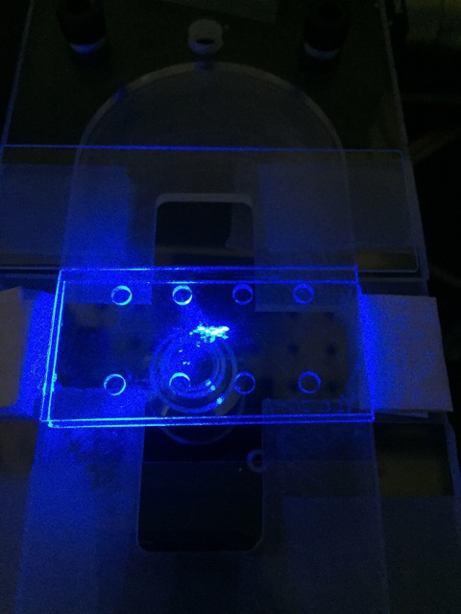

Figure 2. Aligning the laser onto a glass microfluidic device.

