Current Literature Paper
Richard S. Welter

Chapter 1: Alkylation of Nucleophilic Carbon Intermediates

- Enolate Formation-
Lettan, R. B., II; Galliford, C. V.; Woodward, C. C.; Scheidt, K. A.; Amide Enolate Additions to Acylsilanes: In Situ Generation of Unusual and Stereoselective Homoenolate Equivalents, J. Am. Chem. Soc., 2009, 131, 8805-8814.

Amide Enolate Additions to Acylsilanes: In Situ Generation of Unusual and
Stereoselective Homoenolate Equivalents

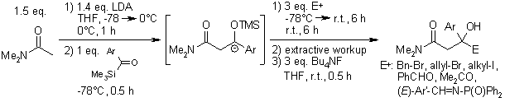

By forming an enolate precursor, the synthesis of β-carboxyl compounds, which are found in many bioactive materials, can be achieved.

- Enamine Formation-
Volkov, A.; Tinnis, F.; Adolfsson, H.; Catalytic Reductive Dehydration of Tertiary Amides to Enamines under Hydrosilylation Conditions, Org. Lett., 2014, 16, 680-683.

Catalytic Reductive Dehydration of Tertiary Amides to Enamines under Hydrosilylation Conditions
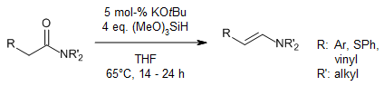

Under hydrosilylation conditions, tertiary amides were reduced to their enamine form using a transition-metal-free catalyst. Enamines that were formed showed high selectivity and excellent yields.

- Dianion Formation-
McNally, A.; Evans, B.; Gaunt, M.J.; Organocatalytic Sigmatropic Reactions: Development of a [2,3] Wittig Rearrangement through Secondary Amine Catalysis, Angew. Chem. Int. Ed., 2006, 45, 2116-2119.

Organocatalytic Simatropic Reactions: Development of a [2,3] Wittig Rearrangements through Secondary Amine Catalysis.

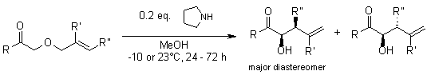

Dianion formation is an essential intermediate step when considering Wittig rearrangements. For this reaction in particular, the dianion formation allowed the further [2,3] Wittig rearrangement using an amine catalyst to successfully synthesize, with incredibly high yields.

- Michael Addition-
Bensa, D.; Constantieux, T.; Rodriguez, J.; P-BEMP: A New Efficient and Commercially Available User-Friendly and Recyclable Heterogeneous Organocatalyst for the Michael Addition of 1,3-Dicarbonyl Compounds, Synthesis, 2004, 923-927.

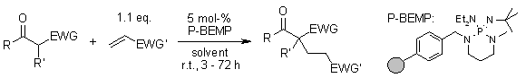
P-BEMP: A New Efficient and Commercially Available User-Friendly and Recyclable Heterogeneous Organocatalyst for the Michael Addition of 1,3-Dicarbonyl Compounds.

Commercially available catalyst P-BEMP was used to successfully synthesize a Michael acceptor without using anhydrous solvents or inert gas at room temperature, with relatively good yields.
Chapter 2: Reaction of Carbon Nucleophiles with Carbonyl Groups

- Aldol Condensation-
Wang, Z.; Yin, G.; Qin, J.; Gao, M.; Cao, L.; Wu, A.; An Efficient Method for the Selective Iodination of α,β-Unsaturated Ketones, Synthesis, 2008, 3565-3568.

An Efficient Method for the Selective Iodination of α,β-Unsaturated Ketones

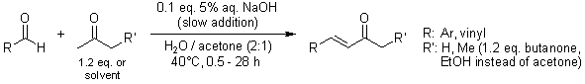

A method was developed using a α,β-unsaturated ketone that underwent aldol condensation to get desirable iodination product, showing very high yields.

- Intramolecular Aldol Condensation-
Nicewizc, D.A.; Satterfield, A.D.; Schmitt, D.C.; Johnson, J.S.; Self-Consistent Synthesis of the Squaliene Synthase Inhibitor Zaragozic Acid C via Controlled Oligomerization, J. Am. Chem. Soc., 2008, 130, 17281-17283.

Self-Consistent Synthesis of the Squaliene Synthase Inhibitor Zaragozic Acid C via Controlled Oligomerization

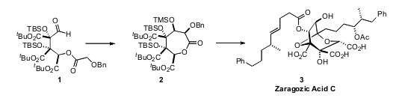
Zaragozic Acid C is an inhibitor of cholesterol biosynthesis. In order for this inhibitor to be synthesized, an early intramolecular aldol condensation step had to occur.

- Mannich Reaction-
Kobayashi, S.; Kiyohara, H.; Yamaguchi, M.; Catalytic Silicon-Mediated Carbon-Carbon Bond-Forming Reactions of Unactivated Amides, J. Am. Chem. Soc., 2011, 133, 708-711.

Catalytic Silicon-Mediated Carbon-Carbon Bond-Forming Reactions of Unactivated Amides

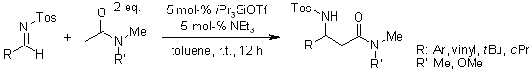

Amides that bears α-proton is less acidic than ketones and aldehydes, which is why many are unactivated. With the mediation of silicon-containing catalyst, the Mannich reaction resumed, forming high anti selectivities.

- Robinson Annulation-
Zhou, P.; Zhang, L.; Luo, S.; Cheng, J.-P.; Asymmetric Synthesis of Wieland-Miescher and Hajos-Parrish Ketones catalyzed by and Amino-Acid-Derived Chiral Primary Amine, J. Org. Chem., 2012, 77, 2526-2530.

Asymmetric Synthesis of Wieland-Miescher and Hajos-Parrish Ketones catalyzed by and Amino-Acid-Derived Chiral Primary Amine

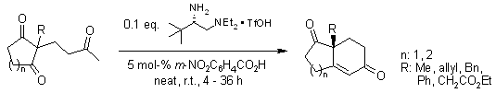

Using Robinson Annulation step, this high-yielding procedure represents an efficient method of chiral building block synthesis.

Chapter 3: Functional Group Interconversion by Nucleophilic Substitution

- Reductive Amination-
Taibakhsh, M.; Hosseinzadeh, R.; Alinezhad, H.; Ghahari, S.; Heydari, A.; Khaksar, S.; Catalyst-Free One-Pot Reductive Alkylation of Primary and Secondary Amines and N,N- Dimethylation of Amino Acids Using Sodium Borohydride in 2,2,2-Trifluoroethanol, Synthesis, 2011, 490-496.

Catalyst-Free One-Pot Reductive Alkylation of Primary and Secondary Amines and N,N- Dimethylation of Amino Acids Using Sodium Borohydride in 2,2,2-Trifluoroethanol

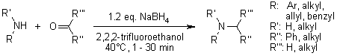

This article shows a convenient procedure to reduce amine groups as well as amino acids without using a catalyst or any other additives. The reduction follows the same mechanism of reductive amination, and interestingly enough, the solvent can be recovered and reused. This article also provided high yields.

- Mitsunobu Reaction-
Muramoto, N.; Yoshino, K.; Misaki, T.; Sugimura, T.; Misunobu Reaction with 4-(Diphenylphosphino)benzoic Acid: A Separation-Friendly Bifunctional Reagent that Serves as Both a Reductant and a Pronucleophile, Synthesis, 2013, 45, 931-935.

Misunobu Reaction with 4-(Diphenylphosphino)benzoic Acid: A Separation-Friendly Bifunctional Reagent that Serves as Both a Reductant and a Pronucleophile

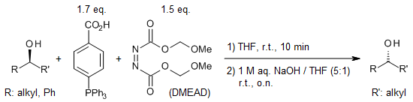

When combined with di-2-methoxyethyl azodicarboxylate (DMEAD), the benzoic acid acts like reductant as well as a nucleophile, thereby allowing the Mitsunobu reaction to occur. In this case, the alcohol group is inverted stereo specifically, and with hydrolyzation, an inverted secondary alcohol is synthesized with pretty spectacular stereo purity results.

- Fischer Esterification-
Chen, C.-T.; Munot, Y.S.; Direct Atom-Efficient Esterification between Carboxylic Acids and Alcohols Catalyzed by Amphoteric, Water-Tolerant TiO(acac)₂, J. Org. Chem., 2005, 70, 8625-8627.

Direct Atom-Efficient Esterification between Carboxylic Acids and Alcohols Catalyzed by Amphoteric, Water-Tolerant TiO(acac)₂

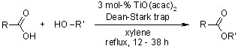

Oxometallic species such as TiO(acac)₂ were used as catalyst to precede a Fischer Esterification reaction. These species are water-tolerant, which allows alkyl/aryl alcohols or aryl carboxylic acids to condense, thus an interconversion of an alcohol to an ester occurs.

- Nucleophilic Acyl Substitution-
Chen, C.-T.; Kuo, J.-H.; Li, C.-H.; Barhate, N.B.; Hon, S.-W.; Li, T.-W.; Chao, S.-D.; Liu, C.-C.; Li, Y.-C.; Chang, I.-H.; Lin, J.-S.; Liu, C.-J.; Chou, Y.-C.; Catalytic Nucleophilic Acyl Substitution of Anhydrides by Amphoteric Vanadyl Triflate, Org. Lett., 2001, 3, 3729-3732.

Catalytic Nucleophilic Acyl Substitution of Anhydrides by Amphoteric Vanadyl Triflate

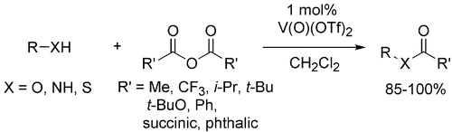

Catalyst vanadyl triflate was the most efficient of the vanadyl species examined to help assist nucleophilic aryl substitution of an ester to an alcohol with high yields and high chemoselectivity.

Chapter 4: Electrophilic Additions to Carbon-Carbon Multiple Bonds

- Oxymercuration-
Song, F.; Watanabe, S.; Floreancig, P.E.; Koide, K.; Oxidation-Resistant Fluorogenic Probe for Mercury Based on Alkyne Oxymercuration, J. Am. Chem. Soc., 2008, 130, 16460-16461.

Oxidation-Resistant Fluorogenic Probe for Mercury Based on Alkyne Oxymercuration

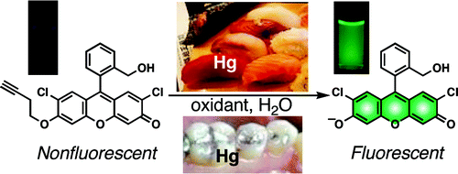

It is known that mercury is a major safety hazard to the general population. Using the oxymercuration reaction, this group found a way to successfully fluoresce molecules on-site. Furthermore, because this fluorescence method provided an 80% overall yield, their next promising approach is to apply this method onto fish and dental samples.

- Iodolactonization-
Denmar, S.E.; Burk, M.T.; Lewis base catalysis of bromo- and iodolactonization, and cycloetherification, PNAS, 2010, 107, 206655-20660.

Lewis base catalysis of bromo- and iodolactonization, and cycloetherification

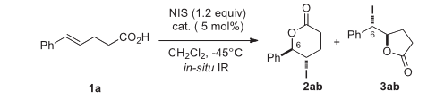

Although this study was more about manipulating catalysts, this reaction used both iodolactonization as well as bromolactonization.

- Wilkinson’s Catalyst-
Cook, S.P.; Polara, A.; Danishefsky, S.J.; The Total Synthesis of (±)-11-O-Debenzoyltashironin, J. Am. Chem. Soc., 2006, 128, 16440-16441.

The Total Synthesis of (±)-11-O-Debenzoyltashironin

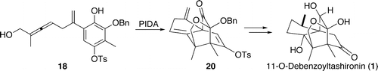

Wilkinson’s catalyst was used as a precursor to finish the synthesis of (±)-11-O-Debenzoyltashironin, which is a natural product.

- Crabtree’s Catalyst-
Tang, W.; Wang, W.; Zhang, X.; Phospholane-Oxazoline Ligands for Ir-Catalyzed Asymmetric Hydrogenation, Ang. Chem., 2003, 42, 943-946.

Phospholane-Oxazoline Ligands for Ir-Catalyzed Asymmetric Hydrogenation

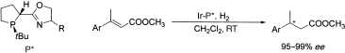

A new class of phospholane-oxazoline ligands for Crabtree’s catalyst was developed to undergo hydrogenation, providing high enantioselectivities.

Chapter 6: Cycloadditions, Unimolecular Rearrangements, and Thermal Eliminations

- Claisen Rearrangement-
Han, X.; Armstrong, D.W.; Using Geminal Dicationic Ionic Liquids as Solvents for High-Temperature Organic Reactions, Org. Lett., 2005, 7, 4205-4208.

Using Geminal Dicationic Ionic Liquids as Solvents for High-Temperature Organic Reactions

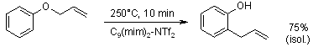

Dicationic ionic liquids are advantageous because these solvents are thermally stable and are sustainable. In this article specifically these solvents were used in the Claisen rearrangement to form the desirable aromatic product.

Chapter 8: Reactions Involving the Transition Metals

- Heck Reaction-
Kantam, M.L.; Srinivas, P. Yadav, J.; Likhar, P.R.; Bhargava, S.; Trifunctional N,N,O-Terdentate Amido/Pyridyl Carboxylate Ligated Pd(II) Complexes for Heck and Suzuki Reactions, J. Org. Chem., 2009, 74, 4882-4885.

Trifunctional N,N,O-Terdentate Amido/Pyridyl Carboxylate Ligated Pd(II) Complexes for Heck and Suzuki Reactions

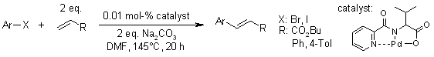

Instead of using phosphine ligands, trifunctional N,N,O-terdentate amido/pyridyl carboxylate Pd(II) complexes were used for the Heck reaction. Results indicated these complexes were highly active and stable, showing high percent yields.

- Suzuki Reaction-
Saito, B.; Fu, G.C.; Alkyl-Alkyl Suzuki Cross-Couplings of Unactivated Secondary Alkyl Halides at Room Temperature, J. Am. Chem. Soc., 2007, 129, 9602-9603.

Alkyl-Alkyl Suzuki Cross-Couplings of Unactivated Secondary Alkyl Halides at Room Temperature

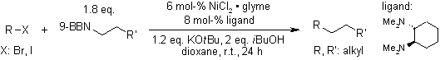

In earlier works, alkyl electrophiles did not work with reagents at elevated temperatures. In order to fix this conundrum, trans-N,N‘-dimethyl-1,2-cyclohexanediamine was used as an effective ligand in order for the Suzuki coupling to work with these Unactivated alkyl halides at room temperature.

- Ring-Closing Metathesis (RCM)-
Castarlenas, R.; Vovard, C.; Fischmeister, C.; Dixneuf, P.H.; Allenylidene-to Indenylidene Rearrangement in Arene-Ruthenium Complexes: A Key Step to Highly Active Catalysis for Olefin Metathesis Reactions, J. Am. Chem. Soc., 2006, 128, 4079-4089.

Allenylidene-to Indenylidene Rearrangement in Arene-Ruthenium Complexes: A Key Step to Highly Active Catalysis for Olefin Metathesis Reactions

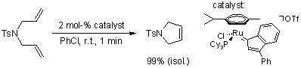

Catalyst HOTf was used to precede RCM of the allenylidene to successfully synthesize an indenylidene product.

