Richard Welter
CH 293
Dr. Lockyear
November 29, 2014
Review on Capillary Electrophoresis
Electrophoresis is the migration or movement of electrically charged particles in a conductive liquid under an applied electric field, a process that was first recorded in 1807 by Russian physicist Reuss. In essence, the objective for electrophoresis is to move and separate such electrically charged particles within a mixture through the medium (Mowry, 1999). Originally, electrophoresis required solvent volumes at the macro level, and it was soon realized that large-scale methods were not only unsustainable, but also time-consuming. It was not until capillary electrophoresis (CE) was introduced that it was possible to reduce solvents to the micro level. The advantages that CE had over previous modes of separation such as liquid chromatography (LC) were apparent. Electrophoresis in a capillary tube has in turn offered numerous exciting methods for fast, highly efficient separations of ionic species (Ewing, 1989). In this paper, I will describe my understanding of the theories involved in CE methods and how these principles pertain to microfluidic devices.
Electrochemistry is at the core of any mode of electrophoresis. Positive electrically charged particles, or cations, travel from the anode to the cathode. This occurrence in electrochemistry has been a way to understand an essential component in electrophoresis, the electric double layer. Capillaries are made from fused-silica. When the capillary is filled with a buffer solution, the electric double layer is immediately created, as long as the pH value of the buffer is greater than 3. This occurs because the inside wall has an excessive amount of negatively charged ionized silanoate groups, so cations from the buffer solution then congregate at the surface of the inner wall. This interface is referred to as the inner-Helmholtz layer (Skoog, 2007). Because there are some remaining cations from the buffer solution, the next layer is referred to as the outer-Helmholtz layer. This layer is the diffuse region of the double layer, consisting of nonspecifically adsorbed hydrated buffer cations (Ewing, 1989). Because these cations are loosely held in this outer layer, the application of an electric field to this system causes these species, as well as neutral particles, to migrate towards the cathode; this wall-driven migration of the bulk solution is called electroosmotic flow (EOF) (Mowry, 1999). To create a separation with a high EOF, ionic strength and buffer are essential to take into consideration. Ionic strength is inversely proportional to the EOF. A buffer with a high pH deprotonates the capillary wall, compressing the electric double layer. As the double layer thins, cations from the buffer will be strongly held at the wall, reducing the zeta potential. The zeta potential is directly related to the EOF (Schwer, 1991). Therefore, having a low ionic strength and high pH buffer will optimize the EOF.
The way analytes migrate to the cathodic side of the capillary tube is also dictated by electrochemical interactions; analyte separation and migration are dependent on the particle’s charge and size. This should make sense because the particle’s charge and size affect the analyte’s electrophoretic mobility (EPM) through the capillary tube, as shown in Figure 1 from Capillary Electrophoresis (Mowry, 1999). For instance, the smaller and more cationic the particle is, the faster the particle will migrate to the cathodic side of the capillary due to the increased electrostatic attraction and reduced friction in solution (Mowry, 1999). Only charged species can be separated based on EPM. With a mixture consisting of different electrically charged ions, the individual analytes would be able to move through the capillary at their respective velocities, which is the primary objective of CE. One of the benefits of electrophoresis in a capillary tube is that the same buffer is applied in the tube, inlet, outlet, and sample vials (Mowry, 1999). By requiring one buffer, this simplification not only shows sustainability in CE, but it also assists the analyte’s net migration toward the cathode.
A major drawback in the inchoate stages of electrophoresis was heat dissipation, and how to control it. Joule heating from numerous sources, including density gradients, convection, friction (viscous resistance to flow) and temperature gradients affected the electrophoretic mobility and could also evaporate the solvent (Ewing, 1989). Temperature control is critical in CE. Migration time, electrophoretic and electroosmotic mobilities, injection volume, and separation efficiency all depend on the temperature (Mowry, 1999). In any mode of separation, minimization of heat is key when separating analytes. This is how CE and microscale applications became so advantageous. The small capillary walls and its ratio of volume to surface area help dissipate the heat when the electrical field is applied and in return, the solvent is thereby able to separate and elute as expected. Moreover, to dissipate heat more effectively, as long as the capillary tube is long with very small inner-diameter, heat will be minimized. A longer capillary tube presents a trade-off between heat dissipation and analysis time. A longer capillary tube will require a longer analysis time (Ewing, 1989).
Although what is mentioned above is important to take into consideration, another facet that has become revolutionary is how to detect each individual analyte migrating through the capillary tube. Since a capillary functions as a “flow-through absorbance cell”, most researchers were originally able to detect the individual analytes using the Beer-Lambert Law (Mowry, 1999). Early CE detectors were actual HPLC detectors that were modified for the smaller volumes of solute going through the capillary. It was soon realized that this was not effective because the path length in these “retro-fitted” HPLC detectors was too small and the detectors were not sensitive enough for CE detection. However, in most cases, the substances that go through the capillary tube do not hold the properties responsible to use this mode of detection. To originally accommodate this, large aromatic groups had to be added to the analyte in order to detect them. In a CE perspective, this accommodation was not appropriate since it required too many derivation steps. Later, electrochemical and laser-based fluorescence was found to be the most sensitive and effective for CE (Ewing, 1989). Fluorescence, unlike UV-vis absorbance detection, is more selective due to the fact that not every compound that absorbs light “subsequently fluoresces.” Such selectivity has provided a more efficient way to detect CE separation (Mowry, 1999).
These theories behind CE methods have not only become very promising in Analytical Chemistry-related fields, but also very applicable in more cutting edge work. Because working at the micro level became such a success, these methods in CE have been used in novel advances such as microfluidic devices. These so-called micro-Total Analysis Systems, or µ-TAS (Harrison, 1993), have enabled a number of important advancements in drug discovery, process control, and healthcare, among other things. To validate this conjecture, I recently went to the Silicon Prairie International Microfluidic Symposium (SPIMS) at the University of Kansas, where there were many presentations regarding the application of microfluidic devices. What I found really interesting was something rudimentary and cost effective like graphite was used as an electrode for one separation process (Coltro, 2014). By attending SPIMS, I recognize how advanced CE has developed over the years and now I can apply these methods into future microfluidic research.

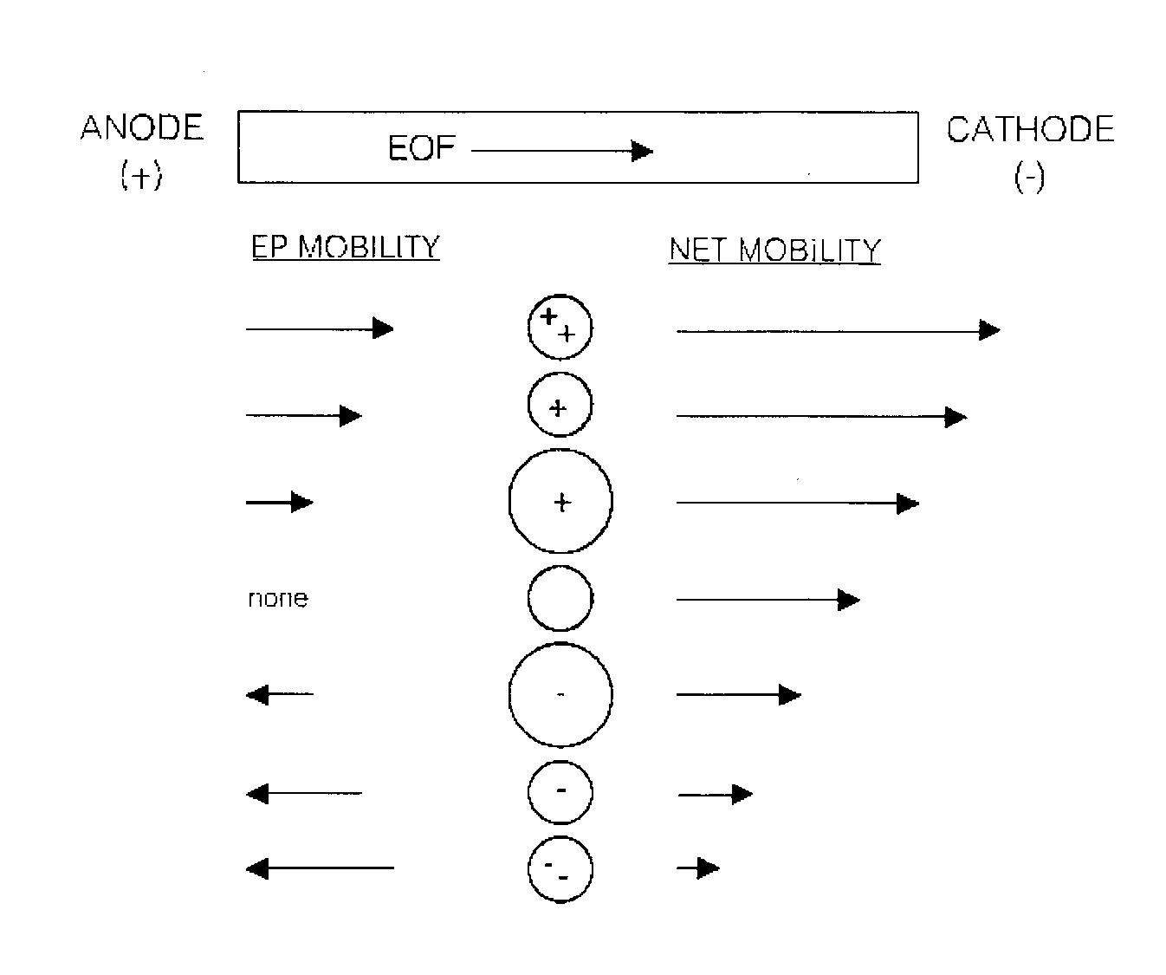
Figure 1, Capillary Electrophoresis

Works Cited
Coltro, W.K.T; New designs for contactless conductivity detection on electrophoresis microchips. Presented at Silicon Prairie International Microfluidics Symposium, Lawrence, Kansas, November 1, 2014.

Ewing, A.G.; Wallingford, R.A.; Olefirowizc, T.M.; Capillary Electrophoresis. Analytical Chemistry. 1989, 61, 292-303.

Harrison, D.J.; Fluri, K.; Seiler, K.; Fan, Z.; Effenhauser, C.S.; Manz, A. Micromachining a Miniaturized Capillary Electrophoresis-Basis Chemical Analysis System on a Chip. Science. 1993, 261, 895-897.

Mowry, Curtis D.; Kelly, Michael J. Capillary Electrophoresis. Encyclopedia of Applied Physics, Update 2; 1999, 3-33.

Schwer, C.; Kenndler, E.; Electrophoresis in Fused-Silica Capillaries: The Influence of Organic Solvents on the Electroosmotic Velocity and the Zeta Potential. Anal. Chem. 1991, 63, 101-1807.

Skoog, D.A.; Holler, J.F.; Crouch, S.R.; Principles of Instrumental Analysis. Cengage Learning. 2006, 869-871.

