Post- Laboratory Write Up
Partners: Nikki DeChant, Taylor Whittaker, and Kenzi Choitz
Introduction: In this lab we got to work with charge in electrostatic situations as well as to revise Coulombs Law, Electric Fields, and the “Triboelectric Series”.
Methodology: To begin the lab, we used an electroscope to measure the quantity of charge of an object charged by friction. In order to do so, we rubbed this plastic rod with fake animal pelt to create the frictional charge. Then we placed this charged rod next to the electroscope thus receiving a measurement of charge, as seen on Figure 6.1
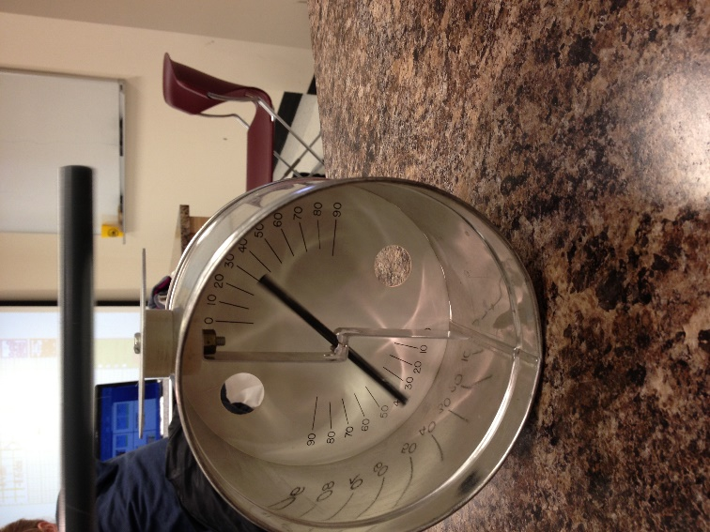
Figure 6.1
We then got to experiment “John Travoltage” (Figure 6.2). The directions stated rubbing his foot on the carpet, and because of the frictional charge traveling throughout his body, he got shocked as he touched the doorknob. Because of the first simulation, we knew what was causing such phenomena, which will be explained in the analysis portion of this lab report.
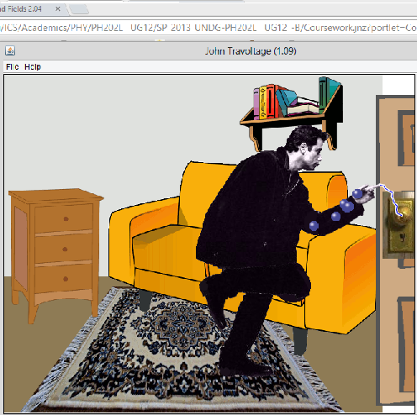
Figure 6.2
To make this lab more exciting than a regular lab, we got to play “Electric Field Hockey”! In class, we learned that opposite charges attract, and similar charges repel. This activity allowed us to play hockey using such principles (Figure 6.3).
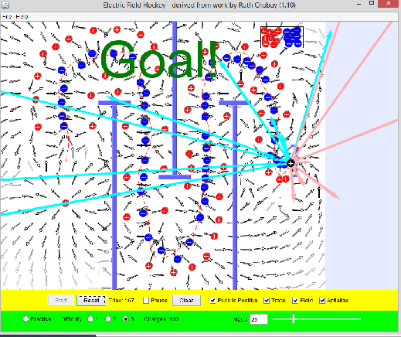
Figure 6.3
After playing that intense game of “Electric Field Hockey”, we then investigated charges and fields (Figure 6.4). We calculated the net electric field, then compared our calculation to the simulation, in order to get our percent error.
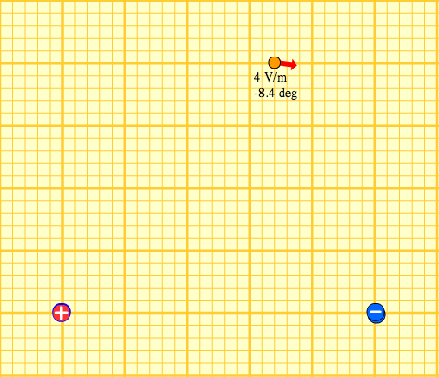
Figure 6.4
Results: $E_{R}=4.02 N/C; \%_{E_{R}}=0.5\%$
$θ_{R}= -8.85°; \%_{θ_{R}}=5.36\%$
Work is shown in Figure 6.5.
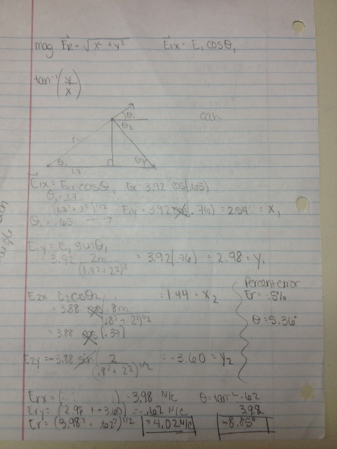
Figure 6.5
Analysis: John Travoltage: By rubbing his leg on the carpet, John built up electrostatic force, thus being a conductor. When he touched the doorknob, the shock emitted visualizes the electron transfer between John and the doorknob (Figure 6.2).
Electric Hockey: The puck initially has a positive charge. After learning about electrons, we learned that same forces repel and opposite forces attract. Figure 6.3 illustrates such relationship.
Electric Field: We are using the same principles of force and applying them in the electric field (Figure 6.1). In order to find the resultant electric force, we had to calculate the x and y components of the forces each charge was acting on each other. Then by comparing our calculations to the simulation, we were then able to find our percent error.
We used the following equations:
$\overline{F}=K_{c}*\frac{\left|q_{1}\right|*\left|q_{2}\right|}{{r_{12}}^{2}}$, where $K_{c}$ is Coulomb’s constant, $q_{1}$ is charge 1, $q_{2}$ is charge 2, and $r_{12}$ is the distance between the two charges.
$$E_{R}= \sqrt{{E_{Rx}}^{2}+{E_{Ry}}^{2}}$$
$E_{Rx}= E_{1}cosθ_{1}+E_{2}cosθ_{2}$
$$E_{Ry}= E_{1}sinθ_{1}+E_{2}sinθ_{2}$$
$$θ_{R}=\tan^{-1}{(\frac{E_{Ry}}{E_{Rx}})}$$
Percent Error: $\frac{\left|E-A\right|}{A}*100$%
Discussion: This lab was by far the most interesting lab to date. There’s a plethora of new concepts I am coming to terms with. Furthermore, I found it peculiar that the kiddos in general physics have touched on this material before the university students. The reason why I said this is because it was awesome to see Kenzi lead the lab since she learned the material before Taylor and I. This lab has also gave me a better idea on how charges behave, which is essential in many of my chemistry courses. I’m enjoying the fact I can integrate many of these concepts into courses that are important to me.

