Post-Laboratory Write Up
Introduction: In this lab, we are to: 1) Reproduce and record the position versus time graph provided in the laboratory by moving in from of a motion sensor; 2) compute average velocity; and 3) try out the chat function on LMS during laboratory period.
Methodology: We were given a position versus time graph of an ant. We calculated the average velocity by taking the slope of the ant. We have learned the slope of a position versus time graph is in fact velocity. The average velocity for the ant was .8 meters per second. Here is the graph of the graph:

I chose my lab partner, Kenzi, to perform the experiment by standing at the .6 meter mark for five seconds, then moving backwards to the 1.4 meter mark by the 15th second. We were able to perform this accurately my measuring those marks using a meter ruler. After the fifth try, due to familiarizing ourselves with the software, we were able to perform this lab.
Results: Our average velocity came out to be .08142 meters per second. We calculated it using Logger Pro. The figure below shows Kenzi performing the lab:
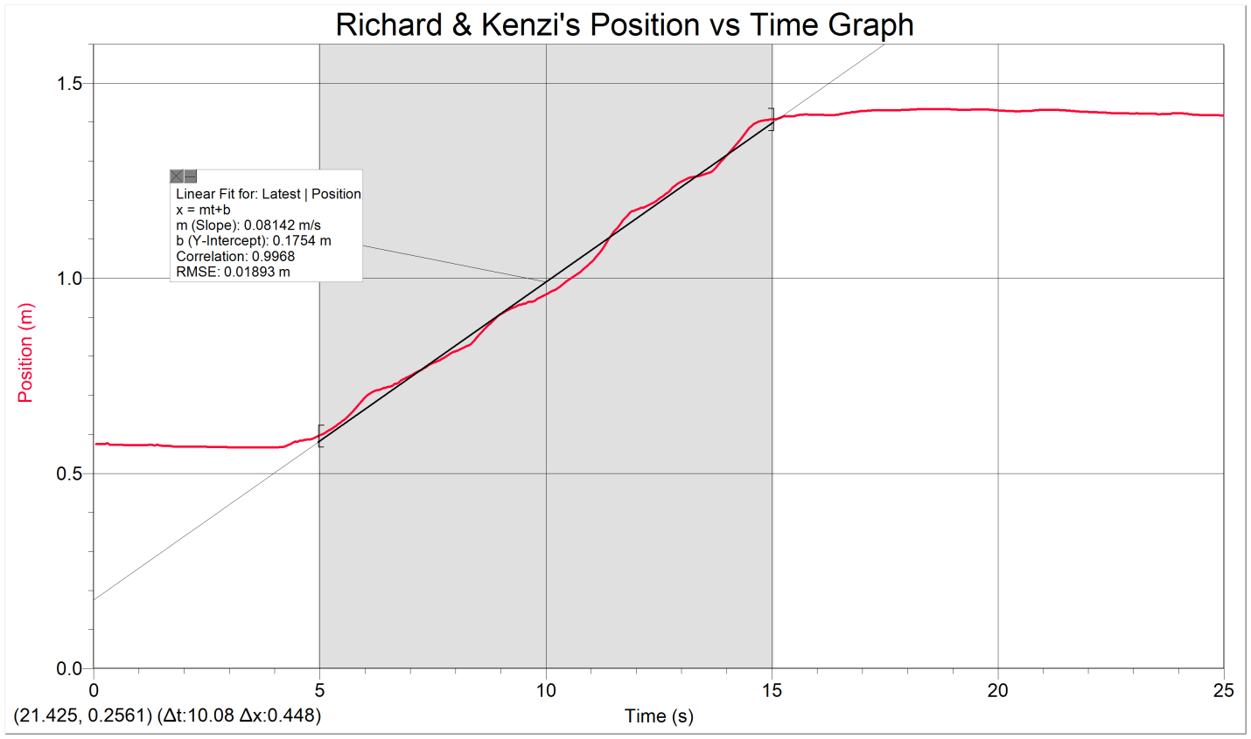
Analysis: Because the Logger Pro software calculated our date entirely, there weren’t a handful of equations we had to use for this lab.
Average velocity: $v= \frac{distance traveled}{time traveled}$
Discussion: I did not collect my information with other groups. However, I compared my results using percent error: $\left|\frac{Actual-Measured}{Actual}\right|*100\%$. Comparing the data Kenzi and I collected from Logger pro, versus the velocity of the ant, we got a percent error of $\left|\frac{.08-.08142}{.08}\right|*100\%= 1.78\%$. This lab taught me numerous things. I need to be more careful when finding my average velocity. There is a huge difference between velocity itself, and average velocity. The pre-lab quiz we took beforehand, I did not convert my units from meters to centimeters. Thus, I need to be more careful when I calculate my data. This not only is essential towards this course, but also any profession I decide to get into.

