Post-Laboratory Write Up
Partners: Nikki DeChant and Kenzi Choitz
Introduction: In this lab, we are to: 1) Make measurements of the pertinent physical properties associated with the fifteen solids provided by the professor, in order to compute the density of each solid; and 2) With the densities, predict the material each solid is made out of.

Methodology: Using a Vernier scale, we had to collect the height, mass, and diameter of each solid in order to calculate the volume and density. Using the Vernier scale will allow us to have a better measurement thus a slim propagation of error. Realizing the solids are different shapes, we obviously had to use different formulas to calculate their respectable volume. However, Solids A-G were too tall to use the Vernier scale; in order to find the height of these solids, we had to use a meter ruler, which created a greater propagation of error. The Figure 1.1 illustrates what solids we were using.
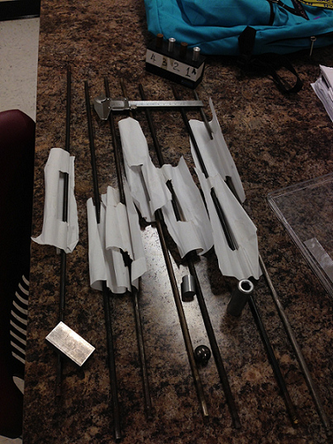
Figure 1.1

Results: After calculated the volume, thus being able to further this investigation by calculating the density of each solid, we were able to predict what each solid was made from. Figure 1.2 will give you a better idea on the calculations we computed, as well as our predictions.
# | Solid | Diameter (m) | Height (m) | Mass (kg) | Volume (m³) | ρ(kg/m³) | ρ(g/cm³) | Predictions
1 | A | 0.0066 | 0.6 | 0.147 | 2.05272E-05 | 7161.2417 | 7.1612417 | Cast Iron
2 | B | 0.0065 | 0.599 | 0.153 | 1.98767E-05 | 7697.470156 | 7.697470156 | Iron
3 | C | 0.0067 | 0.6 | 0.149 | 2.11539E-05 | 7043.613729 | 7.043613729 | Neodymium
4 | D | 0.0064 | 0.6 | 0.146 | 1.93019E-05 | 7564.004457 | 7.564004457 | Samarium
5 | E | 0.0054 | 0.6 | 0.165 | 1.37413E-05 | 12007.57458 | 12.00757458 | Palladium
6 | F | 0.0067 | 0.6 | 0.155 | 2.11539E-05 | 7327.249181 | 7.327249181 | Manganese
7 | G | 0.0064 | 0.599 | 0.162 | 1.92698E-05 | 8406.948032 | 8.406948032 | Copper
8 | A1 | 0.0129 | 0.0499 | 0.018 | 6.52184E-06 | 2759.959171 | 2.759959171 | Aluminum- 3003
9 | A2 | 0.0129 | 0.0508 | 0.055 | 6.63946E-06 | 8283.801341 | 8.283801341 | Brass
10 | A3 | 0.0129 | 0.0509 | 0.018 | 6.65253E-06 | 2705.736005 | 2.705736005 | Aluminum- 6061
11 | A4 | 0.0129 | 0.0499 | 0.053 | 6.52184E-06 | 8126.546449 | 8.126546449 | Nickel- Alloy 825
12 | SPHERE | 0.0186 | - | 0.028 | 3.36928E-06 | 8310.374137 | 8.310374137 | Nickel- Alloy G-3
13 | CUBOID | - | 0.0499 | 0.045 | 1.62874E-05 | 2762.878699 | 2.762878699 | Aluminum- 2024
14 | SHORT CYL | 0.0158 | 0.0231 | 0.013 | 4.52914E-06 | 2870.300173 | 2.870300173 | Aluminum- 7178
15 | OUTER CYL | 0.0189 | 0.0614 | - | 1.72259E-05 | - | -
15 | INNER CYL | 0.0093 | 0.0429 | - | 2.91416E-06 | - | -
15 | H.C. | - | - | 0.039 | 1.43117E-05 | 2725.035578 | 2.725035578 | Aluminum- 1100
 |  |  | http://www.avlandesign.com/density_metal.htm
 |  |  | http://www.argentumsolutions.com/corcalculator/Alloydensity.html
Figure 1.2
Analysis: In figure 1.2, there are several that have a “-“ only because we did not need to calculate it. For example, in order to calculate the volume of the hollow cylinder, we took the difference of the outer cylinder and inner cylinder. The sources we used to predict the solids are also provided in Figure 1.2. We used the following equations for calculation during this lab:
- Volume (Cylinder): $V_{Cl}=π*r^{2}*h$; where $r$ is the radius, and $h$ is the height.
- Volume (Cuboid): $V_{Cu}=l*w*h$; where $l$ is the length, and $w$ is the width.
- Volume (Sphere): $V_{S}=\frac{4}{3}π*r^{3}$
- Density: $ρ=\frac{M}{V}$ , where $M$ is the mass, and $V$ is the volume.
Discussion: This lab of course had error of propagation, especially when we had to use the meter stick to measure solids A-G, as stated earlier in this lab report. To calculate the error of propagation, I’m going to include only Solid A just so it is easier to understand, as well as not having to show the steps over and over again. Using Figure 1.2 as a reference will be important. Since we measured the solids in centimeters with the meter stick, I’m going to multiply the measurement by 1/100. Then, I used the percent uncertainty equation to find my percent error:
.6m$±\frac{.01}{.6}$m .6m$±1.66*{10}^{-2}$ $\left(1.66*{10}^{-2}\right)(100\%)$ .6m$±1.66\%$
After solving the percent error, I took into consideration for the volume:
V: $2.05*{10}^{5}±3*1.66\%=2.05*{10}^{5}±5$
From the value shown, it is evident that the measurement in the meter stick inflicted a major error of propagation to this investigation.

