UV-vis Molecular Spectroscopy Laboratory Report

Richard S. Welter

**Introduction**

Molecular spectroscopy is based on the measurement of transmittance or absorbance of solutions contained in sample containers. Measuring absorption spectra for organic species with known molecular structures, effects of molecular structure and functional groups on absorbance can be easily studied. Absorption of ultraviolet and/or visible radiation usually results from the bonding electrons getting excited; wavelengths of absorption peaks are correlated with the types of bonds that are present. It is then concluded that the absorbance spectrum of any given compound is dependent on the molecular structure in addition to the species’ environment1. In this laboratory specifically, we were to use hydrocarbons/aromatic compounds (Figure 1) and record the absorbance spectra for each and determine the absorbance at λmax and all the peak λ’s. By using Beer’s Law as reference, we are able to determine the aromatic compound’s molar absorptivity (ε), LOD, LOL, and LOQ.

**Experimental**

The following compounds were used as received in this study: Anthracene (Aldrich Chem. Co., Milw., WI 53201; 14,106-2), Naphthalene (Aldrich Chem. Co., Milw., WI 53201; 18,450-0), 1,2-Benzathracene (Aldrich Chem. Co., Milw., WI 53201; B220-9), Benzene (Sigma-Aldrich Co., St. Louis, MO 63013; 443603), and Dibenzothiophene (Aldrich Chem. Co., Milw., WI 53201; D3, 220-2).

Class-A Volumetric Flasks and methanol (Sigma-Aldrich Co., St. Louis MO, 63013; 67-56-1) were used to prepare all standards. 0.1850g of Anthracene was dissolved in 25mL of methanol. This standard was used to create a serial dilution so that the appropriate concentration of 10-4M of Anthracene could be achieved. The procedure calls for the solution to be prepared at a range of 10-4M to 10-7M because if the solution is too concentrated, the “fine” features could not be seen as well; in addition, if the solution is too dilute, there will be no reading at all. The instrument used to detect the atoms in the standard was a UV-2501 PC Spectrophotometer (Shimadzu, Kyoto, Japan). This instrument specifically can run the blank and solution simultaneously. Furthermore, this UV-vis spec contains a PMT transducer and the source is a tungsten lamp.

**Results & Discussion**

The spectra (Figure 2) indicate that my compound in particular—as shown in olive green—was not concentrated enough to detail the fine features like the others. Because of this “bad” reading, we unanimously decided to use Dibenzothiophene, which is represented as the green in Figure 2, for further study. Using the Dibenzothiophene’s spectra, as shown in Figure 2, we were able to calculate ε using Beer’s Law. With a ε value of 42,541 L*mol-1*cm-1, we decided to dilute 1.02x10-4M by a factor of 5 to give us finer peaks, as shown in Table 1. We were able to calculate the concentrations for the five serial dilutions, as shown in Table 1. After calculating the concentrations, we were able to prepare a Beer’s Law calibration plot in order to calculate ε, LOD, LOL, and LOQ, as shown in Figure 3. In order to calculate LOD, we had to determine standard deviation (σ) of the blank absorbance values. After twelve runs of methanol, we calculated a standard deviation value of 1.24x10-3. Since LOD is (3σ/*m*), where *m* is the slope of the calibration curve on Figure 3, we got an LOD value of 6.81x10-8 mol/L. Furthermore, since LOQ is (3*LOD), our LOQ came out to be 2.04x10-7 mol/L. Please note that LOQ and LOD were not plotted in Figure 3 because those values are part of the non-linear regions of the calibration curve. Because we did not have enough absorbance measurements, we are not able to extrapolate a defined LOL value. We assume that the LOL value to be 1.02x10-4M since at this concentration an absorbance of 4.5321 was outside the linear range. And finally, using the slope from Figure 3, ε for Dibenzothiophene is 54546 L*mol-1*cm-1.

Another facet that is important to take into consideration is how molecular structure relates to spectral features. In this lab specifically, benzene was our reference compound because its structure the most basic of the five studied (Figure 1). In solution, benzene has a λmax at 200-210nm. When comparing the other compounds in this study, Naphthalene has a λmax at 225nm, Anthracene has a λmax at 250nm, 1,2-Benzathracene has a λmax at 275nm, and Dibenzothiophene has a λmax at around 240nm. This change in λmax is the result of adding homoannular ring systems onto the benzene ring. For Dibenzothiophene specifically, the thiophene ring is an auxochrome, which means a substitution containing unshared electrons. These substitutions (homoannular and auxochromes) move the absorption maximum to longer wavelengths. That being said, adding homoannular ring systems and auxochromes onto conjugated ring systems result in a bathochromic shift, which is evident by referring to Figure 22.

What can be applied from this is what colors can be emitted, since hydrocarbons with conjugated π-bonds fluoresces and/or phosphoresces. For example, if I were to use Rubrene (a conjugated aromatic compound), absorbs light at a λ of 299nm and 460nm; therefore, we would perceive it red. The color was confirmed from the Sigma-Aldrich website since Rubrene is used for organic LED’s3.

Furthermore, quantitation of amounts of caffeine in coffee and vitamin B in a vitamin tablet can be achieved since caffeine and vitamin B have conjugated π systems, therefore being able to be read in a spectrometer.

**Conclusion**

Using Beer’s Law, I was able to get a better understanding of how UV-vis spectroscopy works. What can be concluded from this laboratory session is how aromaticity plays a major role in the readout; if the compounds we were using were not aromatic, UV-vis spec would not be the route to take. Furthermore, through experimentation, I now understand how molecular structure relates to its absorption max and absorption peaks.



**Figure 1.** Compounds used in this study.

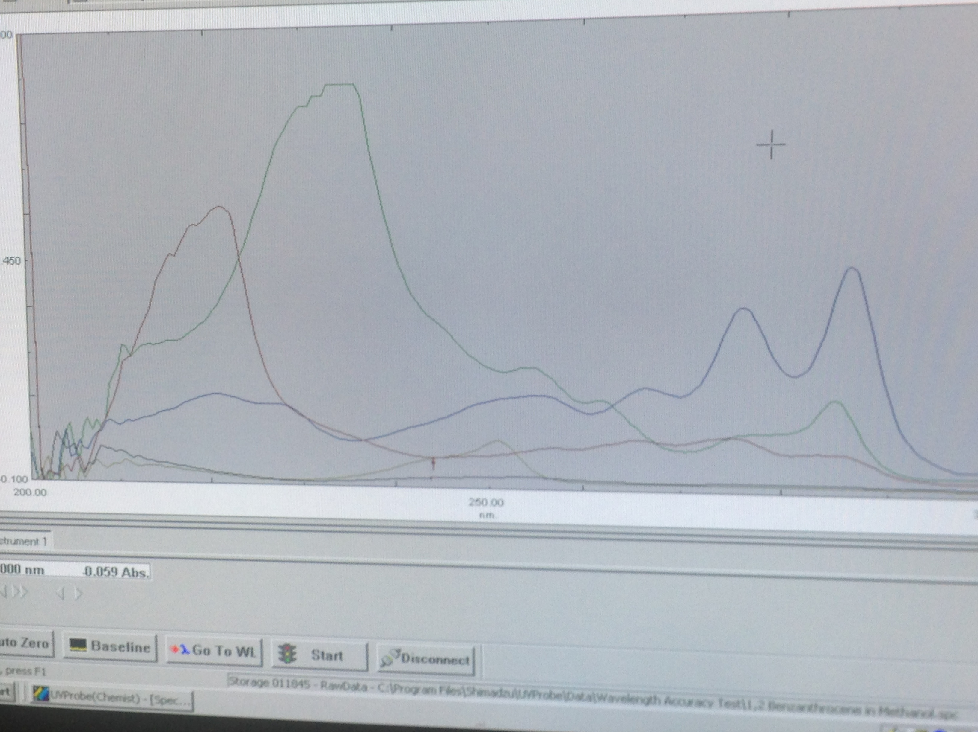

**Figure 2.**  Spectra of aromatic compounds used in this study. Anthracene is Olive Green, Naphthalene is Red, Benzene is Black, 1,2-Benzathracene is Blue, and Dibenzothiophene is Green.

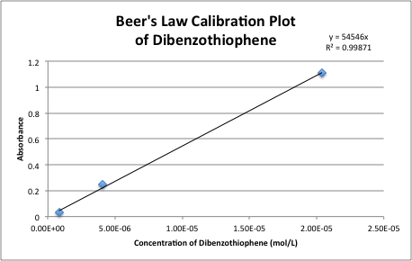

**Figure 3.** Beer’s Law Calibration Plot of Dibenzothiophene.

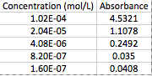

**Table 1.** Using Beer’s Law to calculate concentration of Dibenzothiophene.

Works Cited

1. Skoog, D.A.; Holler, J.F.; Crouch, S.R.; Principles of Instrumental Analysis. Cengage Learning. **2006**.

2. Lambert, J.B.; Shuvell, H.F.; Lightner, D.; Graham, R.; Introduction to Organic Spectroscopy. Macmillon: New York. **1987.**

3. Rubrene. Sigma-Aldrich. http://www.sigmaaldrich.com/catalog/product/aldrich/554073?lang=en&region=US (Accessed April 30, 2015).