The Evolutionary Process of Angiosperms and its Pollinators

Richard Welter
BI350
April 10, 2013

Abstract:
The Plantae Kingdom is definitely underestimated, in terms of its importance as well as its transformation through the evolutionary process. Plants are essentially the backbone of ecology, as well as the foundation of life. Plants are simply autotrophic, meaning able to produce their own food. Although some members of the Animalia and Fungi Kingdom can as well, plants are uniquely photosynthetic, creating their energy by using a light source—the sun—to convert inorganic matter to organic matter in the form of a sugar, in their case, glucose (Campbell, Reese, and et al, 2008). In this paper, I will discuss how plants diversified and transformed through such evolutionary process, the extent of abiotic and biotic vector pollinators’ involvement in the plant world, and then conclude in current research that has discovered that pollinators are still impacting our ecological society.

Introduction:
The arrival of the algae plant was essential for life on earth. These plants originated in the water, which meant the only way such primitive plants were able to reproduce was the sperm cell relying on waterways to travel and hopefully fertilize the egg. This early form of reproduction was indeed hazardous and risky, since the sperm cells could easily be harmed, thus hindering the reproduction process. Through time, however, the early algae plant found a way to “invade” earth, an important period in the plant’s evolutionary process (Attenborough, 1978).
The simple algae then evolved into a more complex non-vascular plant, meaning plants without conductive tissues. This creation was a major evolutionary point because of the way bryophytes changed its reproductive strategies. Known as the alternation of generations, the name itself becomes contradictory when discussing algae simply because the generations are not distinctive from one another. With the newly evolved non-vascular plants, the process became more complex. Fundamentally different from each other, the alternation of generation in these non-vascular plants does not share the same reproductive strategies. For instance, the Gametophyte strategy sexually produces the egg and sperm cells—haploid cells that contains one set of chromosomes. Then, as the sperm and the egg fuse, the second generation emerges: the Sporophyte. Unlike gametophytes, sporophytes reproduce asexually. The sporophyte itself is diploid where there are two sets of chromosomes. In the sporophytes there is a capsule called the sporangium that create haploid reproductive cells called spores. Once the spores leave and germinate, the process repeats and thus forms the gametophyte again (Green).
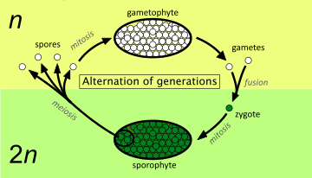

Then, another evolutionary milestone took place: non-vascular plants transformed into even more complex organisms. With the creation of the cuticle and stoma, these new plants found a way to sufficiently survive on terrestrial land. The cuticle was definitely an evolutionary breakthrough. Now that these vascular plants can store water, an undeniable diversity and function in plants emerges from here on out.
During the Carboniferous periods, vascular plants began to diversify; however, some of these plants did not evolve as fully as most plants currently observed today—seedless and seed containing plants. Seedless vascular plants are separated in two clades: the lycophytes and the pterophytes, mosses and ferns respectively. The most distinct nuance between seedless plants and their more evolved counterparts is that their sperm must travel through water to reach the egg, a trait that is seen in the primitive algae. What makes seedless plants so significant, however, is through their evolution journey; their growth in photosynthesis accelerated immensely, thus a dramatic increase in ousting carbon dioxide exposure. The emergence of seed plants altered the evolution process once more. Where seedless rely on water to reproduce, this new transformation of the vascular plant now has more options to reproduce (Green).
Unlike seedless plants, seed plants are heterosporous, meaning such plants can produce more than one kind of spore. Due to evolution, seed plants’ gametophytes have been reduced to microscopic size. By reducing its size, gametophytes are more protected from their surrounding environment, whereas seedless plants have more risks. Seed plants are separated into two specific groups: angiosperms and gymnosperms. “Naked” in Greek, gymnosperms’ seeds are not enclosed in ovaries. Instead, their seeds are exposed primarily in the form of cones (Campbell, Reese, and et al, 2008). “Gymnosperms were the dominant land plants in the age of dinosaurs, the Cretaceous and Jurassic periods,” including plants such as spruce, pine, fir, and redwood (Knee).
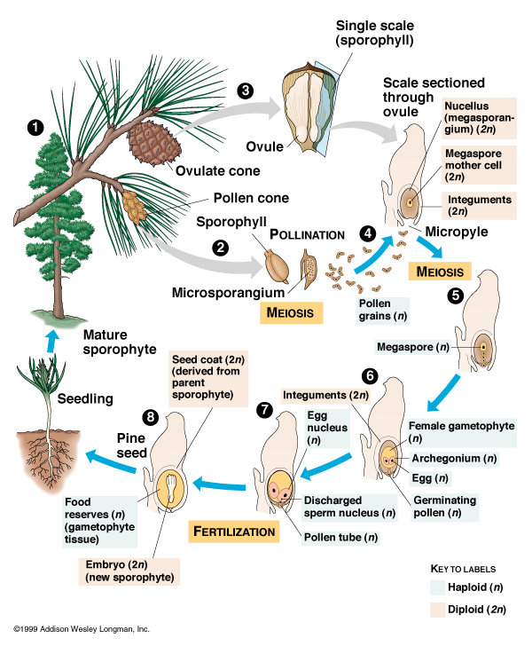
To this day, about one third of forests are gymnosperms. Because their seeds are enclosed in the cone-like structure, it takes a longer time for gymnosperms like conifers to germinate (Attenborough, 1978).
Angiosperms, on the contrary, are structured differently, that is, the seeds are enclosed in a fruit and/or flower. Angiosperms are also separated in two classes: monocots and dicots. Monocots have one cotyledon, which is a nutrient source. In addition, monocots have parallel leaves and many fibrous roots, and its flower parts in three’s. Dicots, on the other hand, have two cotyledons, vein-like leaves, and its flower parts in two’s, four’s, or five’s, depending on the flower (Carter, 2004).
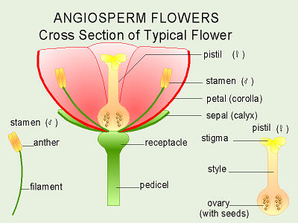
The function of the flower solved many evolutionary struggles of angiosperms. Because most are terrestrial and lack locomotion, there had to be a way for the gametes to travel from plant to plant safely. During meiosis, angiosperms produce microspores and megaspores. Microspores germinate and mature into the male gametophyte in the microsporangium, and megaspores will conversely develop into the female gametophyte in the megasporangium. In the flower itself, angiosperms are categorized to be perfect (both the microsporangia and megasporangia are present) or imperfect (having either microsporangia or megasporangia). With angiosperms that have multiple flowers, it can be either monoecious—both types of imperfect flowers on the same plant—or dioecious—imperfect flowers are present on separate plants. In the actual bud of the flower, the tissues develop into the calyx, corolla, stamens, and carpels. The carpels of the bud act as the female reproductive system. Consisting of the stigma, style, and ovary, fusing together to form a pistil, ovules are developed. The ovule then undergoes meiosis to produce four haploid cells, a large megaspore, and three smaller cells. The stamens of the bud are where the microspores are produced, then will develop into the pollen grain. The pollen grain is made up of a cell with a germ cell that will undergo mitosis to produce two sperm cells (Kimball, 2010).
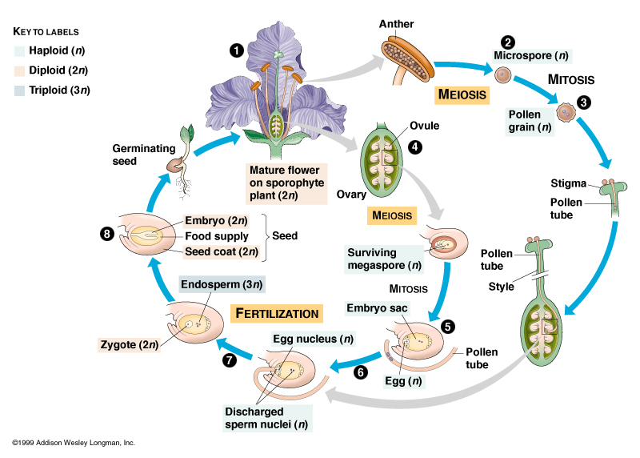
Through such transformation of plant reproduction, the emergence of pollination became a major breakthrough throughout this epic evolution journey. Whilst discussing the methods in which non-vascular plants reproduced—the necessity of a waterway—pollination brings to light a safer, more efficient way to transfer sex cells from one plant to another.
There are two types of pollination: abiotic and biotic. Biotic pollination refers to an animal vector that is responsible for such pollination, and everything else is obviously abiotic, like wind. Gymnosperms like Douglas fir (Pseudotsuga menziesii) rely primarily on abiotic pollination because since it takes a longer time for their seeds to fully germinate, as discussed prior, wind pollination allows the pollen to transfer more efficiently (Attenborough, 1995).
Biotic pollination, however, has evolved in such a way that has become an essential foundation for our ecological society. Discussed in The Dinosaur Heresies: New Theories Unlocking The Mystery of the Dinosaurs and Their Extinction, author Robert T. Bakker, Ph.D. noted that Darwin and his followers had this mindset that through evolution, where such transformation is a consequence, not a cause, “plants and plant-eaters coevolved” (179). Where plant eaters were developing new ways to eat plants, plants would then counteract by toughening fibers by creating cellulose. This back and forth supremacy is evident that not only did plants rely on herbivores, but the herbivores were obviously desperate to eat. How this relates to pollination is simple: plants found a way to evolve into stronger organisms. “Flowering plants first appeared in the Early Cretaceous just after the extinction which occurred at the end of the second grand period (the age of stegosaurs and brontosaurs), and as the replacements for the third grand period (the age of the low feeders) were taking place” (185). Due to this cause and effect relationship plant-eaters and plants share, it was hypothesized the emergence of such revolutionized plant-eaters is what caused the current development of land plants seen today (Bakker, 1986).
Through this journey, seen that male and female sex cells were separated, angiosperms began to combine both cells into one plant. With that in hand, such vectors have shaped and diversified the way plants reproduce. For instance, petals on flowers began to change pigments to attract biotic vectors. With this genetic inheritance, it increased the variability of such pollination, thus having a greater chance for survival in numerous environments. Because there are so many species in this angiosperm family, plants also learned to bloom at different times of the year to prevent self-fertilization. The Columnia plant uses its red “stain glass” leaves as a way to attract, specifically for hummingbirds. Because birds have a similar color range to humans, the translucent blotches act as a sign post. Another general characteristic birds share is a poor lack of smell, which is why most birds are swayed to flowers with a more red/orange petal flowers that are not scented (Attenborough, 1995).
Mammals can also transfer pollen from plant to plant, for example, the Black Lemur (Eulemur macaco) in Madagascar. Nectar is one of the Black Lemur’s main sources of its diet; therefore transporting pollen from one plant to another is manageable. This pollen feeder transports pollen by feeding on the plant’s nectar, and by feeding on numerous plants, the pollen that is dusted on the Black Lemur’s back can be collected by the new recipient plant. Fruit bats can also pollinate. In Borneo, the tropical Durian Tree (Durio zibethinus) has an abundant amount of nectar, a main part of the fruit bat’s diet as well. The flower which contains the nectar and pollen opens during the night hours when the nocturnal fruit bat eats. How the Fruit bat transfers the pollen to other plants is analogous to the Black Lemur’s method (Attenborough, 1995).
The obviously and more recognized vector pollinators are insects, due to being the cheapest and most efficient pollinating service. Because there are a wide range of insects that have the ability to pollinate, angiosperms have altered immensely. The nectar is located deep in the Indian Balsam (Impatiens glandulifera)—an economically produced flower—so in order for a bee to get access to the nectar, the bee has to travel deep in the flower. When the bee gets access to the nectar, the stamens on the roof fall off so that the bee will brush its back on the pollen. Finally, as the bee leaves, the stigma opens for the next bee to deliver pollen. There are some angiosperms that have developed selective traits that prohibit certain pollinators to attain their pollen. Flowers that belong in the Gentiana genus exemplify this method most significantly. These types of flowers offer edible pollen to carpenter bees; when these carpenter bees land on the gentian flower, their vibration slows down, resulting in a deeper buzz; the only way these bees can retrieve the pollen is to vibrate the anthers in a certain frequency in order to release the pollen. This form of pollination is known as buzz pollination (Attenborough, 1995).
David Attenborough’s The Private Life of Plants: The Birds & The Bees served as a source to exemplify how important pollinating vectors are to plant life, which was the foundation in my drive for the upcoming current research. From here on out I will provide some current research in which abiotic/biotic vector pollinators have affected our current ecological society.
Kaplan, M. Bumblebees sense Electric Fields in Flowers. Nature, [Online]. February 21, 2013. http://www.nature.com/news/bumblebees-sense-electric-fields-in-flowers-1.12480 (accessed May 9, 2013).
As discussed in the previous paragraphs, biotic pollinators have a plethora of sensory cues, depending if one is a mammal, insect, or bird (as example). We know that colors, scents, textures, and other characteristics of angiosperms obviously attract these biotic vectors. Most recently, scientists have found an invisible cue insects use to find their nectar and pollen: electric fields. Led by biologist Daniel Robert at the University of Bristol, located in the United Kingdom, the team hypothesized and considered “…that such electrical interactions would temporarily change the electrical status of the flowers…” What came as a surprise to Robert’s team was how bumblebees could also pick up on this since this was the first time such a cue was documented in insects; it was previously only seen in animals like sharks. The team conducted this experiment by observing a common species of bumblebee (Bombus terrestris) by “…using sucrose to lure them into a Faraday pail—and electrically shielded bucket that reacts to the charge of anything inside it.” Results showed the bees carried a positive charge. Next, the team of colleagues placed the bumblebees in an area filled with petunias (Petunia integrifolia) and measured the flower’s electric potential. As the bees landed on the petunias, the flowers became more positively charged. What made this experiment noteworthy was beautifully explained by Robert, “We think bumblebees are using this ability to perceive electrical fields to determine if flowers were recently visited by other bumblebees and are therefore worth visiting.”
Conclusion:
Plants are the foundation; they are what creates, sustains, and saves life in which we thrive. Their evolutionary process is astounding, for plants have had numerous breakthroughs and alterations to not only accommodate, but also compete against its consumers. This cause and effect relationship the Plantae kingdom has with plant-eaters is what diversified and impacted our world the way we currently see it. With that, abiotic and biotic vector pollinators have had to compete with their incredible transformation. From changing their methods of pollination, for instance, relying on a waterway to reproduce in the primitive algae plant, to having the wind and animals to carry out the pollen, their adaptations and those impacts shows just how important plant life is to our world.
References

1. Attenborough, D. The Birds & The Bees. In The Private Life of Plants [VHS], British Broadcasting Corporation: London, 1995.

2. Attenborough, D. The First Forests. In Life on Earth: A Natural History [VHS], British Broadcasting Corporation: London, 1978.

3. Bakker, Robert T. The Dinosaur Heresies: New Theories Unlocking The Mystery of the Dinosaurs and Their Extinction. Kensington Publishing Corp.: New York, 1986.

4. Campbell, Neil, Jane Reece, et al. Biology. 8. San Francisco: Pearson Education, Inc., 2008. Print.

5. Carter, J. Stein. "Angiosperms." Systematic Botany. University of Maryland, 02 Nov 2004. Web. 10 Apr 2013. <http://biology.clc.uc.edu/courses/bio106/angio.htm>.

6. Green, H. The Sex Lives of Nonvascular Plants: Alternation of Generations [video]; CrashCourse Biology #36, http://www.youtube.com/watch?v=iWaX97p6y9U (accessed May 5, 2013).

7. Green, H. Vascular Plants= Winning [video]; CrashCourse Biology #37, http://www.youtube.com/watch?v=h9oDTMXM7M8 (accessed May 5, 2013).

8. Green, H. The Plants & The Bees: Plant Reproduction [video]; CrashCourse Biology #38, www.youtube.com/watch?feature=player_detailpage&v=ExaQ8shhkw8 (accessed May 2, 2013).

9. Kaplan, M. Bumblebees sense Electric Fields in Flowers. Nature, [Online]. February 21, 2013. http://www.nature.com/news/bumblebees-sense-electric-fields-in-flowers-1.12480 (accessed May 9, 2013).

10. Kimball, John W. "Sexual Reproduction in Angiosperms."Kimball's Biology Pages. The Saylor Foundation, 22 Dec 2010. Web. 12 Apr 2013. <http://users.rcn.com/jkimball.ma.ultranet/BiologyPages/A/Angiosperm.html>.

11. Knee, Michael. "Gymnosperms." General Plant Biology. Ohio State University. Web. 10 Apr 2013. <http://www.hcs.ohio-state.edu/hcs300/gymno.htm>.

