Lung-on-a-Chip: A Chemistry Approach to Treat Lung Disease
Richard S. Welter
Having the largest epithelial surface area of the body in contact with the external environment, it is important to recognize what all occurs within the lungs. Penetrating deeper into the lungs, the branching network of the bronchial tubes become shorter, narrower, and more numerous. At the very end of the branching network, the alveoli are the center of discussion since it is the luminal epithelial cells inside the alveoli that mediate gas exchange, which is illustrated by Figure 1. Also known as distal airways (Tavana, 2010), these alveolar ducts are prone to close at low volumes. When the alveoli are at low volumes, mechanical and/or fluid-mechanical stresses occur (Douville, 2011). A natural way to alleviate stresses in these liquid-lined flexible tubes (Cassidy, 1999) is the production of surfactant, which reduces surface tension nearly to zero at the air-liquid interface (Tavana, 2010); in addition, reducing the surface tension allows gas exchange to resume, thereby preventing these airways from collapsing, shown in Figure 2. However, if there is surfactant dysfunction, large libraries of respiratory disorders are induced such as neonatal respiratory distress syndrome (NRDS), pneumothorax (collapsed lung), and asthma, among others.
In order to have an effective method that can further the studies of lung treatment, macroscale analysis is not promising. On the contrary, electrophoresis, the process in which a liquid mixture is separated based on the particles’ size and charge, has become a major factor not only in Analytical chemistry, but also in health-related fields. In the beginning stages, the separation process was performed at the macro level and it was soon realized that due to time consumption and unsustainable amount of solvent required, there was a need to perform electrophoresis at the micro level. With reproducible success on microscale amounts, a protocol of introducing lung-on-a-chip is a promising approach to potentially further the studies of or even treat lung disease.
Before delving into potential contenders to treat lung disease, understanding what surfactant really is and its role in the alveoli is of importance. Consisting of 90% lipids and 10% proteins (Figure 3), this complex structure is produced from type II alveolar cells. The majority of the lipids in surfactants are amphiphatic phospholipids, more specifically, dipalmitoylphosphatidylcholine (DPPC) (Hohlfeld, 2001), that respond to the surface tension caused from inspiration and expiration. With this response, cyclic ventilation of the lungs resumes. There are several types of surfactant-associated proteins (SP) involved: SP-A and SP-D, which are hydrophilic, hydrophobic SP-B and SP-C, and together, they allow the fluid to spread throughout the epithelial lining. This lining is important for the alveoli, since it acts as a defensive barrier to invading microorganisms (Alonso, 2004). With the activity from the lipids and proteins, the body is able to avoid atelectasis—the event at which the lung collapses after expiration—and resume gas exchange at the liquid-air interface. That is why pulmonary surfactant is so important to have in the human body. It is the surfactant that allows these distal airways to remain elastic in order for the lung to be able to function the way it does. For newborns especially, the surfactant present allows their first inspiration to occur with few complications. Since surfactant is produced during the later months of the gestation process, premature babies have higher chances of developing pneumothorax because of the absence of surfactant.
Early methods to treat RDS involved using mechanical ventilation, which maintains constant pressure and volume in spontaneous breathing via ventilators. However, large ventilation pressures can damage the airway walls, that is, peel apart the epithelial cells, which showed poor results (Ghadiali, 2000). Instead of ventilation therapies, a promising method to treat NRDS included replacing the surfactant with other previously developed surfactants: classified by natural, modified natural, and synthetic. Natural surfactants are more prone to cause more allergic reactions to patients, but since infants are of concern, their premature immune systems make the allergic response very rare. For synthetic surfactants, their performance is not as successful as natural surfactant replacement due to their inability to mimic “the chemical complexity of a natural surfactant” (Ghadiali, 2000). Though it does not seem promising to use synthetic surfactants, Ghadiali’s group hypothesized that the overall effectiveness of surfactant replacement is dependent on the surfactant’s dynamic surface tension properties, not on whether the surfactant is natural or synthetic. When the airway closes, the surface tension that follows will create laminar flow that block any airflow from passing, thereby creating a liquid plug. Looking at the size of the liquid plug will show the effectiveness of the surfactant replacement (Cassidy, 1999). The way to test the size of the liquid plug was by mimicking the mechanical stress via a syringe pump pressurizing a capillary tube. Using a glass capillary tube, the specific type of surfactant—SDS, DPPC, and Infasurf were specifically used in this study—would expand the tube, and whichever surfactant was able to generate the smallest liquid plug would be the most effective. Though the data indicated there were significant nuances between the different types of surfactants, many limitations arose, including the fact that the surfactant adhered to the glass capillary wall, creating static surface tension. Furthermore, the measurements were taken in a “steady-state condition” and therefore could not relate to the lung accurately because a steady-state condition can never occur in vivo (Ghadiali, 2000).
The endeavor that enabled this protocol to come to fruition was a remarkable success using cells in separations. Though capillary electrophoresis became a very advantageous method, complications were still evident. Not only was the analysis time slow, a low throughput of cells separating in a capillary tube was seen as well; only 8-10 cells could be separated and analyzed in a given day (McClain, 2003). A solution to put an end to that was by injecting the cell sample into a microfluidic device. Such devices have several advantages that standard capillaries cannot come even close to, and that is substantially reducing separation time while keeping high separation efficiencies simultaneously (McClain, 2003). In addition, changing the material of the substrate opened the avenue for lung treatment analysis. Early-staged separation processes were on glass substrates until the arrival of the polymeric substrate, poly(dimethylsiloxane) (PDMS). Constructing and maintaining polymeric substrates is not only cheaper than glass but it requires less tedious work. But most importantly, its elasticity allows the PDMS microfluidic device to have epithelial bilayer-like properties (Duffy, 1998). This characteristic is what will advance further studies to treat lung disease using microfluidic devices.
It has been hypothesized that the liquid plug that is formed from the mechanical stress generates deleterious fluid stresses, characterized by large wall shear (Huh, 2007). To test this conjecture, creating an in vivo airway model to test pulmonary epithelial cells with air bubbles revealed a significant result: mechanical stresses created by bubble progression does cause severe cell damage. A way to detect the mechanical stresses was by the crackling sound it produced when the liquid plug ruptured. The airway model that was used consisted of two PDMS chambers that were separated by a thin, polyester porous membrane. This model (Figure 4) represented the apical and basal compartments of the epithelium, respectively. The thin membrane is what mimics the in vivo basement membrane, which provides support for cell attachment and growth. What was significant about this project was not only that the microfluidic device nicely represented an airway but it also induced cellular differentiation that caused airway epithelial cells to express the morphological and secretory phenotypes found in vivo (You, 2002). By using a microfluidic device, mechanical injury of human small airways was successfully investigated, which furthers the studies on how to handle a main contributor to several induced lung diseases.
It is noted that existing models that study functional and metabolic properties of the lung are only limited to animal models. Animal models have are difficult to control, and it is cumbersome to harvest specific cells for analysis. Thus, there is a need for models that can give very precise control at the cellular level. A way that can be achieved is providing a culture system on a microfluidic device. That way, a physiologically relevant scale model can give high throughput results (Nalayanda, 2009). With a similar microfluidic design to what was discussed before (Huh, 2007), what were different between the two experiments were the cells that were used for separation: human alveolar basal epithelial cells known as A549 cells. This novel continuously perfused microfluidic system of human alveolar cells enabled monolayers to be successfully grown when exposed to air for several weeks. Unlike the previous project (Huh, 2007), this study focused on long term and stable culture at the air-liquid interface instead of being exposed briefly at the interface (Nalayanda, 2009). This microfluidic device offered several advantages, including continuing in vivo parameters such as closely packed cells with constant nourishment and waste removal. In addition, the cells that were cultured over the membrane were not disturbed by any fluid flow, since the flow of media is limited to the basolateral surface of the cell layer. Therefore, any secreted molecules from the cells remained in the extracellular liquid. This open system was also able to perform surfactant droplet tests that would not be possible in a closed system. This project emulates alveolar epithelium that provides an estimate of pulmonary permeability of a new drug in future work. It can be said that microfluidics play an important role in optimizing parameters to further study lung development, injury, and regeneration (Nalayanda, 2009).
Now that there is progression in the in vivo lung-on-a-chip analysis, improving previous work underscores the importance of using a microfluidic device. It has been recognized that abnormalities in both the biophysical and biochemical properties of surfactant causes a liquid plug that obstructs airflow and puts gas exchange to a halt (Tavana, 2010). However, although liquid plugs have been previously studied via capillary tubes (Cassidy, 1999; Ghadiali, 2000), putting a microfluidic device up to the test is what makes this overall protocol even more advantageous. Though these previous studies have advanced what it means to work at the micro level for treating lung disease ailments, it has been very difficult to recreate pulmonary airway-associated flows in vitro (Tavana, 2010). For instance, the Tavana group had already developed a microfluidic device containing a plug generator and cell culture chamber; however, the device lacked reproducible control and measurement of pressure levels, making it very difficult to fully replicate a lung. They were able to improve the microfluidic device so that it was fully capable of functioning as a lung in vivo, and also found out that exogenous surfactants do provide protective coating films on distal airway walls, thereby reducing flow instability-induced airway closure (Tavana, 2010). Similar to Huh’s model (Huh, 2007), Tavana’s group developed a microfluidic device with two PDMS chambers that were separated by a porous membrane, which mimicked the basement membrane in vivo. Their results showed that adding multiple buffer and surfactant solutions created instability in the flow of the microchannels; this instability the liquid plugs. This work reveals a better understanding of cellular-level effects of liquid plugs and an overall efficacy of preventive and treatment strategies for various respiratory disorders (Tavana, 2010).
As alveolar epithelial cells stretch and relax during inspiration and expiration respectively, any disturbances result in solid mechanical stress. When the air-liquid interface propagates over the airway and epithelial cells, shearing and pressure gradients cause fluid mechanical stress to occur. A combination of solid and fluid mechanical stresses is hypothesized to consequently induce VILI (Douville, 2011). There have been studies that explored solid mechanical stresses individually in vivo; however, there has been difficulty extending the techniques found in solid mechanical stress systems to an in vitro modeling of the alveolus, that is, including both solid and fluid mechanical stress in a microfluidic system. Systems that solely study fluid mechanical stresses failed due to the inability to stretch and relax, as denoted in Figure 5. In this study, Douville’s team presented a way to study both solid and fluid stresses simultaneously in order to examine their total and individual effects. The microfluidic device was designed differently than Huh’s and Nalayanda’s. The device consisted of two microchannels that were separated by an elastic PDMS membrane. The device itself had three component layers: an alveolar chamber for A549 cell culture, the flexible PDMS membrane for transmitting stretch, and the last layer being an actuation channel to control the stretch and meniscus propagation. The meniscus propagation was chosen to be included in the microfluidic device in order to match strain values and surface tension forces in the alveolus (Douville, 2011). In order for the cells to be distributed uniformly on the PDMS membrane surface, the microfluidic device was elevated vertically during cell seeding. It is important to note that the size of the microfluidic device does not correspond to the dimensions of typical alveoli; however, it is nicely represented in vitro. This study showed that it is possible to create a microfluidic system that can represent both solid and fluid mechanical stresses, indicators of VILI. Furthermore, surfactant enrichment can in fact reduce these mechanical stresses. With this first successful system to incorporate both solid and fluid mechanical stresses, there is now access to additional studies on other surface tension diseases that affect alveoli. This study is now a nice representation to study ventilation strategies that can be used to potentially treat lung disease.
In either a pre- or clinical setting, animal models are usually tested for treatment of human diseases. However, using animal models is time-consuming, very expensive, and most importantly, they often do not accurately predict adverse effects in humans, that is, they fail to provide sufficient human organ functionalities. Major pharmaceutical companies and government funding agencies like U.S. Food and Drug Administration (FDA) and National Institutes of Health (NIH) have finally recognized that there is a crucial need for new technologies that can not only predict efficacy in humans more quickly but more reliably as well (Huh, 2012). New technologies were developed to recapitulate the physiological and mechanic microenvironment of living organs. Altering the way we apply in vitro human models on a microfluidic device may revolutionize current drug development methods. Up to this point microfluidics has not been shown to mimic complex human disease processes or to even predict human responses to pharmaceutical agents at relevant dosage; consequently, it has failed to meet pharmaceutical agencies’ standards to be used as models. However, Huh’s group cultured two types of human lung cells in parallel microchannels that were separated by a thin membrane. The upper channel functioned as an alveolus and was filled with air, and the bottom channel functioned as the microvascular channel, which was filled with liquid. This microfluidic model successfully “breathed rhythmically much like a living lung” (Huh, 2012). Pulmonary edema, the disease Huh’s group focused on, is characterized by abnormal accumulation of intravascular fluid in alveolar air ducts, which leads to vascular leakage. This condition is the result of hydrostatic pressure, permeability produced by various diseases, or even by dose-limiting drug toxicities (Huh, 2012). To successfully mimic pulmonary edema on the microfluidic device, Huh and his colleagues perfused a dose of interleukin-2 (IL-2)—which induces pulmonary leakage—to the microvascular channel, and leakage into the alveolar channel occurred. A follow up with injection of angiopoietin-1 (Ang-1) was tested to see if it inhibited IL-2, since Ang-1 has been shown to stabilize endothelial intercellular junctions. When Ang-1 was administered with IG-1, there was success in halting vascular leakage. In addition, Ang-1 prevented gap formation in the presence of mechanical strain (Huh, 2012). Finally, to be able to fully convince the companies that denied the usage of microfluidic devices in a clinical setting, Huh’s group tested their microfluidic model against a new pharmacological agent from GlaxoSmithKline GSK2193874, which blocks certain ion channels that are activated by mechanical strain. GSK2193874 has been preliminarily validated in animals but still need to be confirmed in humans (Huh, 2012). With the addition of GSK2193874 there was no sign of leakage, indicating this model can be a viable treatment option for patients with pulmonary edema who are currently under a mechanical ventilator.
With evidence of manipulating major contributors to lung disease such as solid and fluid mechanical stresses, and even treating the lung disease itself, lung-on-a-chip microfluidic devices have been shown successfully to be a potential strategy to treat lung disease. Not only will this approach be cost effective, this novel area is a remarkable platform to further lung disease studies. By applying the lung-on-a-chip protocol to clinical experimentation, results such as those from Huh’s group indicates sufficient potential to treat even more severe lung diseases such as pneumothorax and cancerous diseases.

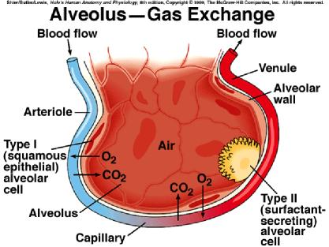

Figure 1. Illustration of the gas exchange that takes place in the alveoli (Tamarkin, 2011).

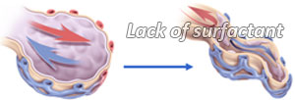
Figure 2. Illustration of alveolus with absence of pulmonary surfactant (Casals, 2008).

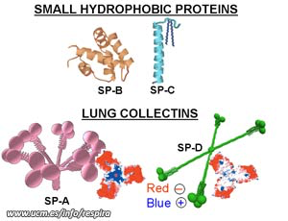
Figure 3. Illustration of pulmonary surfactant (Casals, 2008).

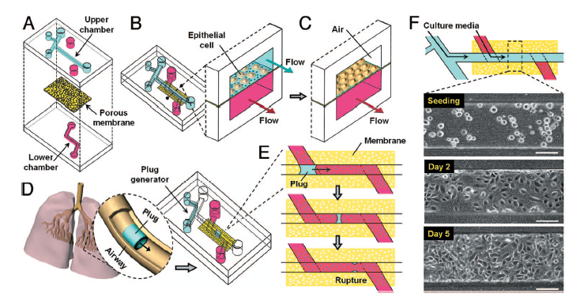
Figure 4. Microfluidic device depicting the human lung (Huh, 2007).

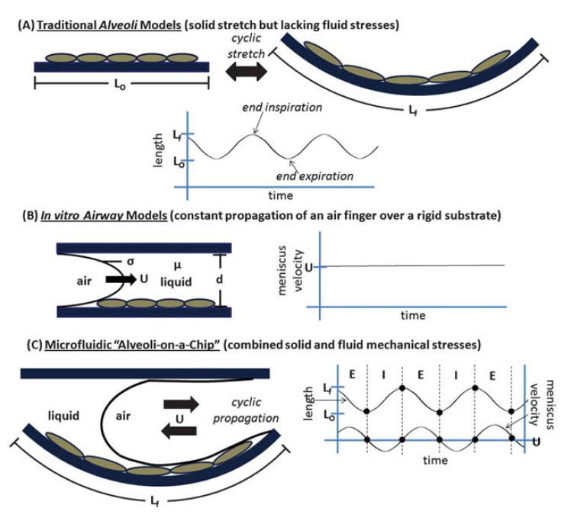
Figure 5. Diagram of previous microfluidic alveolar models (Douville, 2011).
Works Cited

Alonso, C.; Alig, T.; Yoon, J.; Bringezu, F.; Warriner, H.; Zasadzinski, J.A.; More Than a Monolayer: Relating Lung Surfactant Structure and Mechanics to Composition, Biophysical Journal, 2004, 87, 4188-4202.

Douville, N. J.; Zamankhan, P.; Tung, Y.; Li, R.; Vaughan, B. L.; Tai, C.; White, J.; Christensen, P. J.; Grotberg, J. B.; Takayama, S.; Combination of fluid and solid mechanical stresses contribute to cell death and detachment in a microfluidic alveolar model, Lab Chip, 2011, 11, 609-619.

Duffy, C. D.; McDonald, C. J.; Schueller, J. A. O.; Whitesides, M. G.; Rapid Prototyping of Microfluidic Systems in Poly(dimethylsiloxane), Anal. Chem., 1998, 70, 4974-4984.

Casals, C. Respira: Respiratory Epithelium and Pulmonary Surfactant, 2008, http://pendientedemigracion.ucm.es/info/respira/index.php?sec=Overview+of+Lung+Surfactant (Accessed April 20, 2015).

Cassidy, K. J.; Halpern, D.; Ressler, B. G.; Grotberg, J. B.; Surfactant effects in model airway closure experiments, J. Appl. Physiol., 1999, 87, 415-427.

Ghadiali, S. N.; Gaver, D. P.; An investigation of pulmonary surfactant physicochemical behavior under airway reopening conditions, J. Appl. Physiol., 2000, 88, 493-506.

Hohlfeld, J.M.; The role of surfactant in asthma, Respiratory Research, 2001, 3, 1-8.

Huh, D.; Fujioka, H.; Tung, Y.; Futai, N.; Paine, R.; Grotberg, J. B.; Takayama, S.; Acoustically detectable cellular-level lung injury induced by fluid mechanical stresses in microfluidic airway systems, PNAS, 2007, 104, 18886-18891.

Huh, D.; Leslie, D. C.; Matthews, B. D.; Fraser, J. P.; Jurek, S.; Hamilton, G. A.; Thorneloe, K. S.; McAlexander, M. A.; Ingber, D. E.; A Human Disease Model of Drug Toxicity-Induced Pulmonary Edema in a Lung-on-a-Chip Microdevice, Sci. Transl. Med., 2012, 4, 1-8.

McClain, M. A.; Culbertson, C. T.; Jacobson, S. C.; Allbritton, N. L.; Sims, C. E.; Ramsey, J. M.; Microfluidic Devices for the High-Throughput Chemical Analysis of Cells, Anal. Chem., 2003, 75, 5646-5655.

Nalayanda, D. D.; Puleo, C.; Fulton, W. B.; Sharpe, L. M.; Wang, T.; Abdullah, F.; An open-access microfluidic model for lung-specific functional studies at an air-liquid interface, Biomed Microdevices, 2009, 11, 1081-1089.

Tamarkin, D. A.; Alveolar Gas Exchange, 2011, http://faculty.stcc.edu/AandP/AP/AP2pages/Units21to23/respiration/alveolar.htm (Accessed April 20, 2015).

Tavana, H.; Kuo, C. H.; Lee, Q. Y.; Mosadegh, B.; Huh, D.; Christensen, P. J.; Grotberg, J. B.; Takayama, S.; Dynamics of Liquid Plugs of Buffer and Surfactant Solutions in a Micro-Engineered Pulmonary Airway Model, Langmuir, 2010, 26, 3744-3752.

You, Y.; Richer, E.J.; Huang, T.; Brody, S.L.; Growth and differentiation of mouse tracheal epithelial cells: selection of a proliferative population, Am J Physiol Lung Cell Mol Physiol, 2002, 283, L1315-L1321.

