Post-Laboratory Write Up

Partners: Chance Colson, Joe Wolf, and Tanner Wallace

Introduction: In this lab, we are to: 1) Observe completely inelastic collisions between two carts, testing for the conservation of momentum; and 2) Measure energy changes during completely inelastic collisions.

Methodology: We began this lab my measuring the mass of the two carts. Then, like we have been doing for most of our labs, we connect Logger Pro to calculate our work. Figure 8.1 illustrates how Chance moved Cart 1 so that it would collide with Cart 2. We will be using a velocity versus time graph to calculate momentum because the peak is when the collision occurs and the plateau will denote the velocity of both carts (Figure 8.2 & 8.3).



Figure 8.1

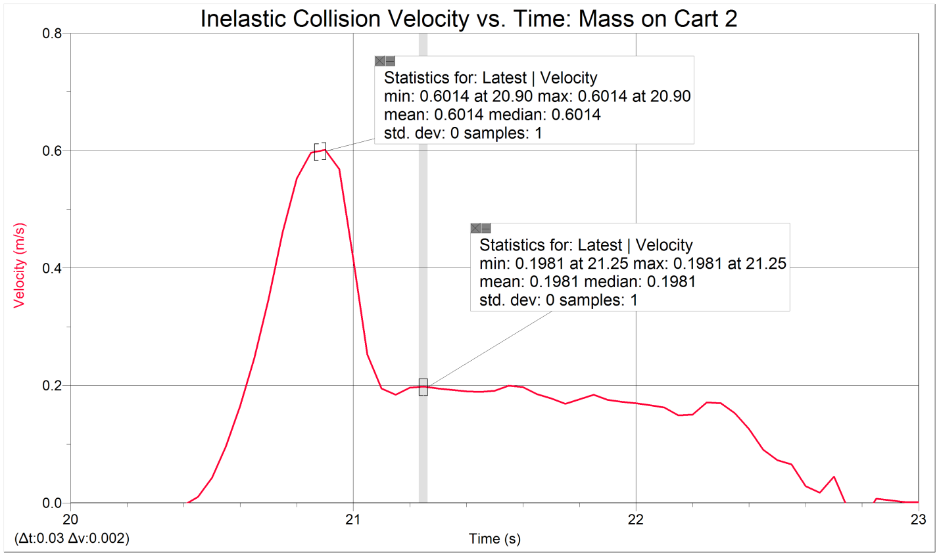

Figure 8.2

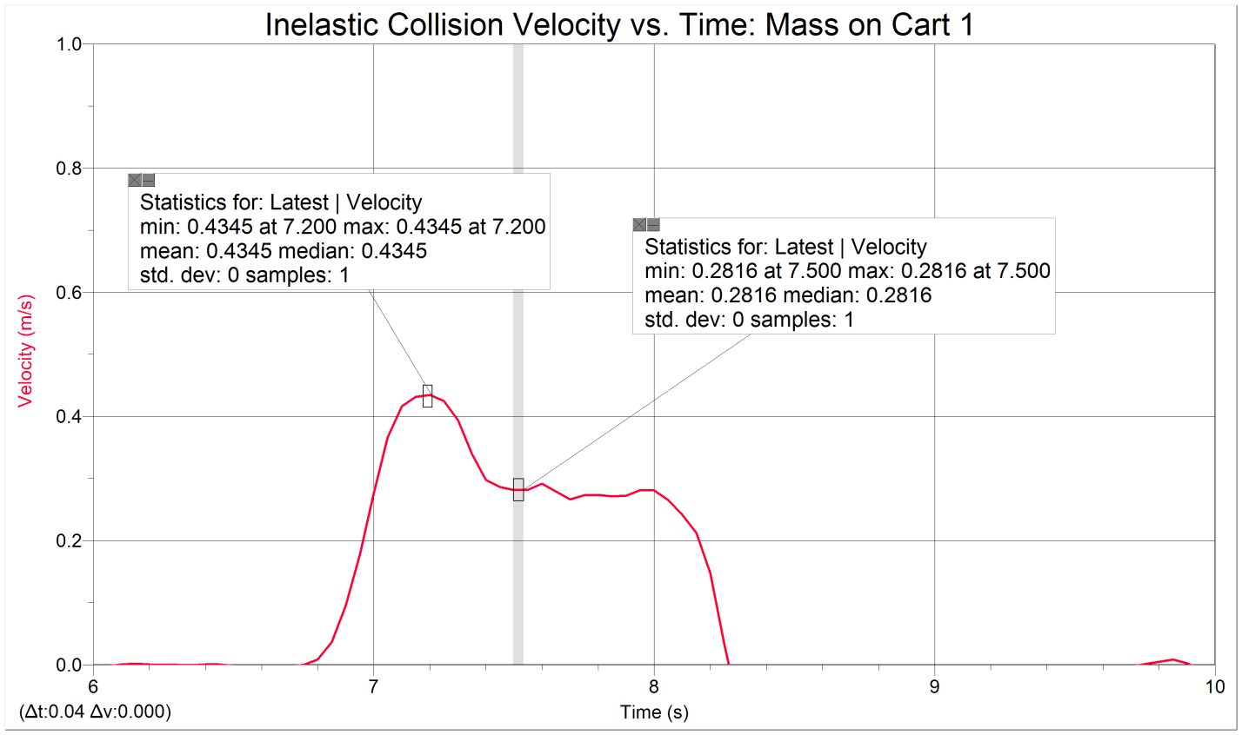

Figure 8.3

Results:

|  |  |  |  |  |  |  |  |  |
| --- | --- | --- | --- | --- | --- | --- | --- | --- |
| Mass of cart 1 (kg): .516 | | Mass of cart 2 (kg): .510 | | | Additional Mass (kg): .506 | | |  |
|  |  |  |  |  | |  |  |  |
| Run number | Net Mass of Cart 1 (kg) | Net Mass of Cart 2 (kg) | Velocity of cart 1 before collision | Velocity of Cart 2 before collision (m/s) | | Velocity of cart 1 after collision | Velocity of cart 2 after collision |  |
|  |  |  | (m/s) | (m/s) | (m/s) |  |
| 1 | 0.516 | 0.51 | 0.7017 | 0 | | 0.3408 | 0.3408 |  |
| 2 | 1.022 | 0.51 | 0.4345 | 0 | | 0.2816 | 0.2816 |  |
| 3 | 0.516 | 1.016 | 0.6014 | 0 | | 0.1981 | 0.1981 |  |
|  |  |  |  |  |  |  |  |  |
| Run number | Momentum of cart 1 before collision | Momentum of cart 2 before collision | Momentum of cart 1 after collision | Momentum of cart 2 after collision | Total momentum before collision | Total momentum after collision | Ratio of total momentum | Percent Error (%) |
| after/before |
|  | (kg•m/s) | (kg•m/s) | (kg•m/s) | (kg•m/s) | (kg•m/s) | (kg•m/s) |  |
| 1 | 0.3620772 | 0 | 0.1758528 | 0.173808 | 0.3620772 | 0.3496608 | 0.965707866 | 3.429213438 |
| 2 | 0.444059 | 0 | 0.2877952 | 0.143616 | 0.444059 | 0.4314112 | 0.971517749 | 2.848225123 |
| 3 | 0.3103224 | 0 | 0.1022196 | 0.2012696 | 0.3103224 | 0.3034892 | 0.97798032 | 2.201968018 |
|  |  |  |  |  |  |  |  |  |
| Run number | KE of cart 1 before collision | KE of cart 2 before collision | KE of cart 1 | KE of cart 2 | Total KE before collision | Total KE after collision | Ratio of total KE | Percent Error (%) |
| after collision | after collision | after/before |
|  | (J) | (J) | (J) | (J) | (J) | (J) |  |
| 1 | 0.127034786 | 0 | 0.029965317 | 0.029616883 | 0.12703479 | 0.0595822 | 0.469022717 | 53.09772829 |
| 2 | 0.096471818 | 0 | 0.040521564 | 0.020221133 | 0.09647182 | 0.060742697 | 0.629641883 | 37.03581173 |
| 3 | 0.093313946 | 0 | 0.010124851 | 0.019935754 | 0.09331395 | 0.030060605 | 0.322144831 | 67.7855169 |

Analysis: Because the Logger Pro software calculated our date entirely, there weren’t a handful of equations we had to use for this lab. However, in the Excel sheet, we had to perform our calculations. In Figure 7.1, for trials 1-3, the values came from the maximums of what Logger Pro calculated.

Momentum: $p=m_{1}v_{1}$

Kinetic Energy: $KE=\frac{1}{2}m_{1}v_{1}^{2}$

Percent Error: $\left|\frac{Actual-Measured}{Actual}\right|*100\%$

Discussion: I did not collect my information with other groups. However, I compared my results using percent error. Because my Excel sheet was too big to fit on this word document, I could not include the average percent error for both momentum and kinetic energy. We have learned in class in any collision, whether it is elastic or inelastic, momentum is always conserved. However, depending on the collision, kinetic energy is not. We expected this to occur as we calculated the percent error. The values came out to be 2.83% and 52.64% error respectively, though.